THE WORD
Fox Hill Central United Methodist Church
Pastor Eric Vaudt August 2017

MISSION STATEMENT
To Know and Experience Christ and to make him known.

Last month, Peggy and I took some time away for some rest and relaxation and rest assured, while your pastor and his wife were gone they did, in fact, attend worship services on Sundays. We first visited a church in Littleton, NC, which is part of a 4-point charge. Their senior pastor has been there 13 years and their associate is a part-time local pastor who has been there for 3 years.

We were sitting next to another couple that was visiting and the senior pastor made sure to stop by and introduce himself to them and ask their names. As he walked around the front of the pews to the other side, he walked by us and then stopped to come over to us but did not introduce himself. He merely said good morning. The associate was content with standing by the piano and not engaging anyone. We accepted the pastor’s blanket invitation to stay for fellowship and a couple of people engaged us in conversation, but not near as much as the other couple. Most of all, no one ever said, “Welcome to ___________ United Methodist Church.”

The Sunday after that we worshipped in a church on the York River District, and we might as well had been invisible. No one came and said, “Welcome to ___________ United Methodist Church. My name is _______________.” All the hospitality was reserved for those of that church and not for visitors, and that’s not the first time I have experienced not being welcomed in God’s house.

I spent 2 weeks in Brunswick, Maine while on instructor duty and over the weekend I found a UMC where I worshipped. No one welcomed me; no one invited me to stay for fellowship and on the way out the door, the pastor said, “Thanks for coming.” Which of these churches do you think I’m inclined to visit again?

When Jesus instructed the disciples in Matthew 10, he told them that if any particular town did not welcome them that they were to shake off the dust of their feet on that town and move on. In John 13, Jesus says: “I give you a new commandment, that you love one another. Just as I have loved you, you also should love one another. By this everyone will know that you are my disciples, if you have love for one another.”

Friends, I wrote about hospitality in June and also tried to have a couple of meetings centered on revamping our greeter ministry because I believe God’s Welcome is vital for any church! If we don’t extend God’s Welcome, no one will come. Why should they? Why would they? We can, and we must, do a better job. Showing God’s Welcome is not the responsibility of the same two or three people or only the pastor: it’s ALL of our responsibility, and not just inside God’s house of worship. We must share God’s Welcome wherever we go. But it is imperative that God’s Welcome is shown to ALL visitors inside the house of worship. I promise, they won’t bite! It’s okay to say, “Good morning! My name is ___________, welcome to Fox Hill Central,” and then introduce them to someone else.

God freely welcomes us into his grace. If we have experienced God’s welcome then, as disciples, we must do the same.

Pastor Eric

VISION STATEMENT - To encourage and strengthen our church family to be proactively engaged in ministry
as the hands and feet of Christ within Fox Hill and beyond. We embrace human needs through intentional
worship, a passionate prayer life, faithful participation in Bible study, active witnessing, individual and small
group discipleship and Christian love.

Peggy’s Corner
EXPLORE THE MYSTERIES OF ISAIAH BY PEGGY VAUDT.
In my studies, I have reached the glorious book of Isaiah. (Hint, this is in the OLD TESTAMENT! [tee hee]) Here, in the NIV version, I have lifted some verses from Isaiah Chapter 1 setting forth God’s opinion of Judaism during the time of the Kings. Does anyone see the Church of today?

Hear the word of the Lord,
you rulers of Sodom;
listen to the instruction of our God,
you people of Gomorrah!
“The multitude of your sacrifices—
what are they to me?” says the Lord.
“I have more than enough of burnt offerings,
of rams and the fat of fattened animals;
I have no pleasure
in the blood of bulls and lambs and goats.
When you come to appear before me,
who has asked this of you,
this trampling of my courts?
Stop bringing meaningless offerings!
Your incense is detestable to me.
New Moons, Sabbaths and convocations—
I cannot bear your worthless assemblies.
When you spread out your hands in prayer,
I hide my eyes from you;
even when you offer many prayers,
I am not listening.
Wash and make yourselves clean.
Take your evil deeds out of my sight;
stop doing wrong.
Learn to do right; seek justice.
Defend the oppressed.
Take up the cause of the fatherless;
plead the case of the widow.
Your rulers are rebels,
partners with thieves;
they all love bribes
and chase after gifts.
They do not defend the cause of the fatherless;
the widow’s case does not come before them.
Zion will be delivered with justice,
her penitent ones with righteousness.
But rebels and sinners will both be broken,
and those who forsake the Lord will perish.

I do not think this needs a single word of explanation from me. - Peggy

2
HYMNOLOGY 101 BY PEGGY VAUDT - Ancient Words by Lynn DeShazo
Born and raised in Birmingham, Alabama, Lynn DeShazo is a graduate of Auburn University and the Christian Life School of Theology. Lynn has lived in Birmingham nearly all her life. She plays the guitar and considers her music education more “hands on” than traditional. She admits to always having an interest in music and songs at first playing favorite songs by ear on her guitar. She then graduated to worship songs and soon began writing her own. She has now written over 350 songs in a career spanning over 30 years and has written exclusively for Integrity Music since 1989. Of interest, most people believe that Michael W. Smith wrote this song, as it appeared on one of his albums. Several songs done at our 8:30 service are Lynn’s. We do not sing this song, and believe it or not, this has been severely “panned” by some English majors. Shame on them. Every time I sing these words, I feel God stir inside ne.

Holy words long preserved
for our walk in this world,
They resound with God’s own heart.
Oh let the ancient words impart.

Words of Life, words of Hope
Give us strength, help us cope
In this world, where e’er we roam
Ancient words will guide us Home.

CHORUS:
Ancient words ever true
Changing me and changing you,
We have come with open hearts
Oh let the ancient words impart.

Holy words of our Faith
Handed down to this age
Came to us through sacrifice
Oh heed the faithful words of Christ.

Holy words long preserved
For our walk in this world.
They resound with God’s own heart
Oh let the ancient words impart.

CHORUS:
Ancient words ever true
Changing me and changing you,
We have come with open hearts
Oh let the ancient words impart.

SYMPATHY - The Pastor and congregation of Fox Hill Central United Methodist Church extend deepest sympathy to the family of Paul Kline who passed away July 1.

THANKS - Thanks everyone for your thoughts, prayers, cards and visits during my recent hospital stay. A special thanks to Pastor Eric for his prayers and visits. I'm very thankful for my church family.
"Skippy" Cole

3

PRAYER CONCERNS
Military Members: Alex Burbanck, Robbie Bessette, Daniel Roederer, Kaitlyn Routten Ellis, Austin Mason

Community: Faith Brehm, Clara Davis, Rosella Johnson, Selma Ward, Helen Williams, Libby Wilson, Suzanne Gibson (Bethany UMC), Anne Rakes, Rev Henning Poulson, James Kline, George Black, Keith Rowe

Assisted Living and Nursing Home:
Elizabeth and Charlie Compton, Commonwealth Assisted Living at Hampton

Marian Elliott, Seton Manor, 215 Marcella Rd, Apartment 612, Hampton VA 23666 851-1762

Helen Wallace, has moved in with her daughter, Betty Ann Rosser. Her new address is 310 Kinsman Way, Hampton VA 23666.

Extending the Table is conducted under the rites of the United Methodist Church, endorsed by the Administrative Board of Fox Hill Central, and under the supervision of Rev Eric Vaudt. The Shepherds have made this part of their ministry as they visit those who are unable to come to church and participate in our Lord’s Supper. Visits are scheduled for the first of each month. If you know of someone who is in need of this ministry please call the church office at 851-2040.

WHATS HAPPENING AT FOX HILL CENTRAL UNITED METHODIST CHURCH

MEMBERSHIP CLASS - The pastor's next membership class will begin the first Sunday of September during the Sunday school hour. Please contact the church office to let your intent be known.

FOX HILL HISTORICAL SOCIETY meeting will be Saturday, August 12, at 2 PM, at Fox Hill Central UMC.

THE BOOK CLUB - The book club will meet August 31 in the Fidelis classroom to discuss A House Divided by Robert Whitlow. The October book will be Boston Girl by Anita Diamant. Everyone welcome, come join us.

JEAN RAINES CIRCLE - There will be no meeting in August.

MOVIE NIGHT - August 26, 630 PM, "The Shack". Popcorn and drinks will be provided.

YOUTH will be going to Higher Ground August 10-13. Reminder - don't forget Vacation Bible School August 20-24, flyer attached on Page 7. The youth will resume meeting September 10.

BREAD OF LIFE – come join us on Saturday, August 26 at 1030 AM.

4

STEWARDSHIP will be doing monthly work days to help those in our church and community, if you have a need or know of someone who does, please contact Alann Hudson.

Friday Night Bible Study. Sam Joplin is teaching on Philippians. There will be a time of praise, prayer, Bible study and fellowship. All are welcome.
Locations: August 4, Debbie Bessette, 224-0923
August 11, Alann Hudson, 851-9060
August 18, Trevoe Alston, 920-9751
August 25, Gayle Joplin, 851-4650

Wednesday Morning Bible Study every week at 10 AM at the church.

Joyful Women of Faith meets the 1 and 3 Thursday of each month at 7 PM at the church.

DEADLINE for the September issue of The Word will be August 27.

SCHOOL KITS - School supplies are beginning to go on sale. Please think ahead to school kits for next year. It's a great time to build up our needed supplies - especially packages of notebook paper (150 sheets, college or regular ruled). As always, we can shop for you if you choose to contribute money. Any questions, please call Alann Hudson, 851-9060. Thanks and God bless you.

THE MIGHTY "GREEN" CUCUMBER
Just one cucumber contains Vitamins B1, B3, B5, B6, C, Folic Acid, Calcium, Iron Magnesium, Phosphorus, Potassium, and Zinc…or most of the vitamins you need in one day.
Tired in the afternoon? Put down the caffeine and pick up a cucumber. The pick-me-up can last for hours. Good for late night snack, too.
Eating cucumber before bed may even help keep the early AM headache at bay. Cucumbers have been used by trappers, traders and explorers to thwart off starvation.
Need a quick shoe shine? Rub a cucumber on your shoes. Also helps repel water.
Out of WD40? (Made from bananas.) Rub a cucumber slice on that squeaky hinge.
No time to brush and no gum or mints handy: Press a slice of cucumber to the roof of your month for about 30 seconds to eliminate the bacteria that causes bad breath.
A "green" way to clean your faucets, sinks or stainless steel is to rub a slice of cucumber over the area you want to clean and wipe off. It won't leave streaks and won't harm your hands.
Rub cucumber skins slowly over unwanted pen marks, crayon and marker wall décor.
And by the way, anyone can grow a cucumber plant in a large pot with a tomato cage or trellis for it to climb. Put it in a sunny spot and water often.

5
STEWARDSGIP COMMUNITY WORK DAYS
(Pictures Courtesy of Jan Spencer)

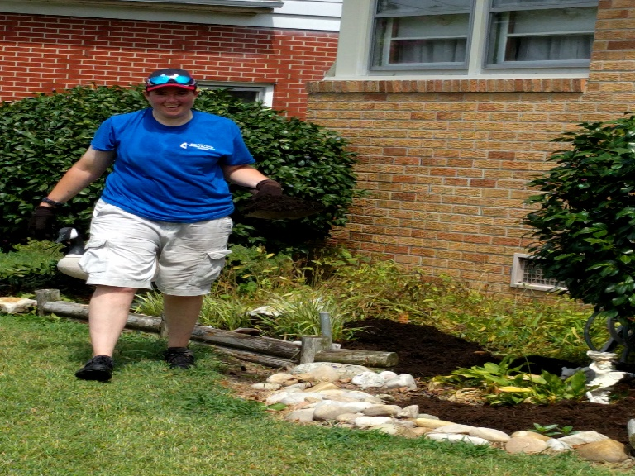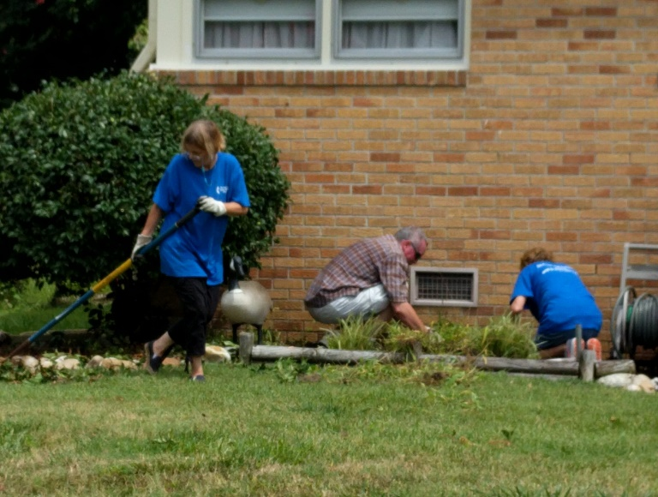
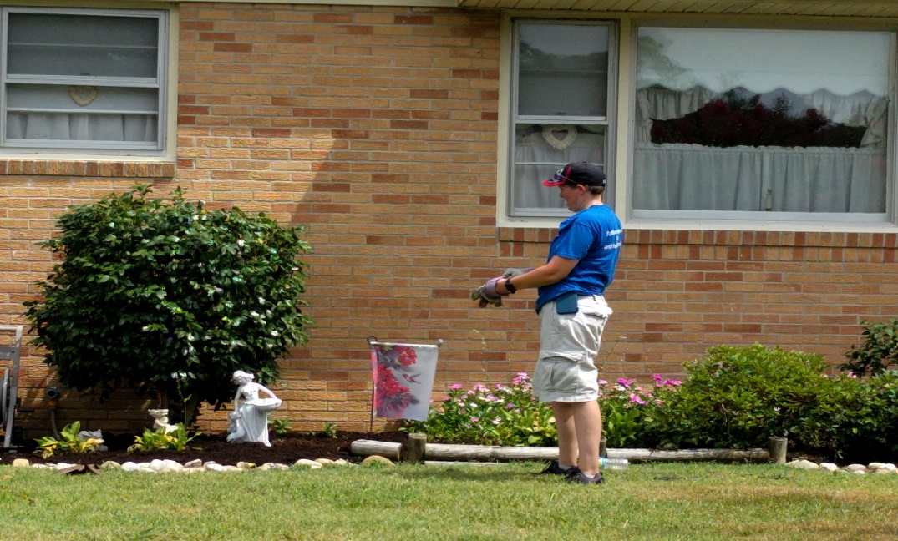

6
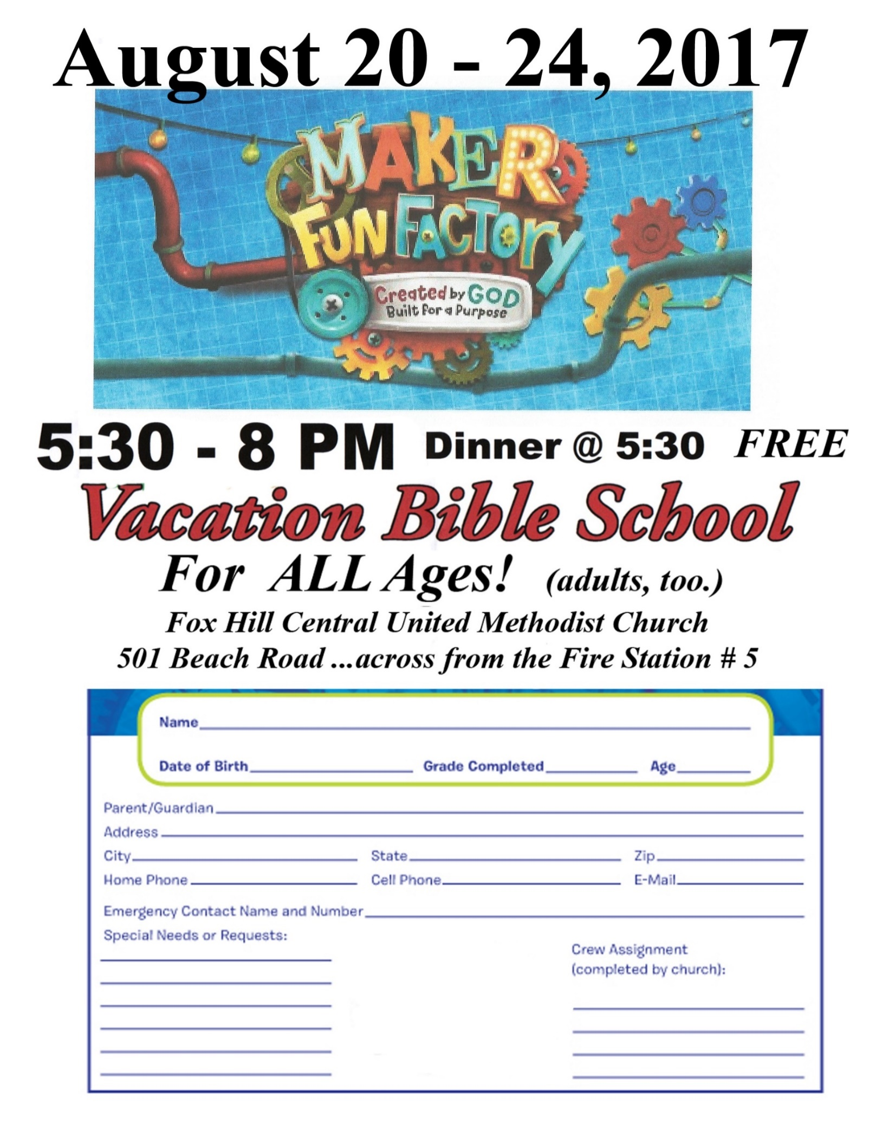
7
AUGUST BIRTHDAYS
Chris Ames August 1
Debbie Andrus August 5
Linda Melson August 6
Mallory Bailey August 7
Rick Routten August 9
Dan Wesson August 11
Michael Melson August 13
Tommy Evans August 18
Mary Lou Roaseau August 27
Rod Johnson August 28

AUGUST LAY LEADERS
August 6 Ushers Rod Johnson Butch Kilmon
John Fowler Tom Cooke
Greeter P.J. and Wanda Routten
Communion Ushers Pete Raines, P.J. Routten

August 13 Ushers P.J. Routten Tommy Evans
Neal Forbes Orson Duhe
Greeters Alann Hudson and Tanya Mason

August 20 Ushers Jan Spencer Alann Hudson
Debbie Bessette Linda Melson
Greeters Debbie and Tracy Andrus

August 27 Ushers Eddie Melson George Black
Freddie Rowe John Brehm
Greeters George and Jessie Kay Black

Bell Ringer: Butch Kilmon Usher for Back Door: Freddie Rowe, Tommy Evans

AUGUST FLOWER CALENDAR
August 6, Tracy Andrus The Flower Calendar is posted on the Bulletin Board. If you
August 13, Sammie Duhe would like to place flowers in church for a special occasion
August 20, Raines please check the calendar and write your name in the
August 27, None appropriate block. Thanks

8
AUGUST 2017 CALENDAR
Sunday | Monday | Tuesday | Wednesday | Thursday | Friday | Saturday
NOTE - Sunday Services
8:30 AM - Rise and Shine Service
9:45 AM - Sunday School
11:00 AM - Morning Worship Service
 |  | 1 | 2  10 AM - Bible Study | 3  7 PM - Joyful Women of Faith | 4  7 PM - Friday Night Bible Study -Debbie Bessette | 5 |  | 24 | 25  10:00AM Bread of Life
6  See Note for  service times | 7 | 8 | 9  10 AM - Bible Study | 10  Youth - Higher Ground  Aug 10-13 | 11  7 PM - Friday Night Bible Study – Alann Hudson | 12  2 PM -  Fox Hill  Historical  Society
13  See Note for  service times | 14  615 PM - Finance  7 PM - Admin Council | 15 | 16  10 AM - Bible Study | 17  7 PM Joyful Women of Faith | 18  7 P M - Friday Night Bible Study - Trevoe Alston | 19
20  See Note for  service times  530-8 PM  Vacation  Bible School | 21  530-8 PM  Vacation  Bible School | 22  530-8 PM  Vacation  Bible School | 23  10 AM - Bible Study  530-8 PM  Vacation  Bible School | 24  530-8 PM  Vacation  Bible School | 25  7 PM - Friday Night Bible Study - Gayle Joplin | 26  1030 AM  Bread of Life  630 PM - Movie Night
27  See Note for  service times | 28  Dinner Buddies | 29 | 30  10 AM - Bible Study | 31  7 PM - Book Club

9
Fox Hill Central UMC
501 Beach Road
Hampton VA 23664

Return Service Requested

The WORD, August 2017

Fox Hill Central United Methodist Church Church E-mail - fhcumc@gmail.com
501 Beach Road Pastor E-mail - ericvaudt@vaumc.org
Hampton VA 23664 Office Hours: Monday - Thursday
(757) 851-2040 9:00 AM - 1:00 PM

Pastor Eric J. Vaudt, Cell (757) 759-7484
Administrative Assistant: Carole Anne Pabst
Music Director: Ralph Snowden
Custodian: Donna Coburn
Nursery: Cheryl McCrary and Rosemarie Kidd

10

