THE WORD
Fox Hill Central United Methodist Church
Pastor Eric Vaudt September 2017

MISSION STATEMENT
To Know and Experience Christ and to make him known.

Being that it is now September, it is the last month of the third quarter of 2017 with one quarter to go. It is this last quarter that gets particularly busy as our various committees prepare for Charge Conference and students head back to school (faculty have already returned!). The retail world will soon begin their commercialization of Christmas, holiday plans will soon be made regarding dinners, parties and travel, and the Nominations and Leadership Development Committee will be doing the Lord’s work so the church is ready to lead in ministry in 2018.

During the last two Sundays of August, the committee provided a short spiritual gifts inventory to everyone in worship, which will be used in its work of discerning the leadership that is needed. There is always kingdom work to be done, and I have yet to meet anyone by the name of “Someone Else.” Why do I say that? Well, I have to wonder how many thought to themselves, “Someone else will do it.” Why not you? We all have something we can do for God and there are always opportunities to serve the Lord. The Body of Christ is comprised of all of us: we are all an important part of the body.

As Paul dealt with the Corinthian church and all their issues he told them, “Now you are the body of Christ, and each one of you is a part of it.” (1 Cor 12:27) I can’t do what others can, and many of you cannot do what I can. That is how God made us! In order to be a fruitful part of the body of Christ, we need each other and those gifts. We may, or may not, have the same gifts, but our gifts are needed nonetheless. So that is why, when the Nominations and Leadership Development Committee meets, we begin with a time of Bible study and prayer so that we can “discern what is the will of God.” (Romans 12:2)

So here is the difficult part of this process. Some will be asked to serve the Lord in some fashion, and the answer will be “no.” My prayer will be that we open ourselves to God’s leading and truly spend time listening for God’s voice, to truly discern what it is that God wants us to do. My prayer is that no one will tell God, “I can’t…” When I was still a member of Community UMC in Virginia Beach some time ago, I had confided in a friend of ours before singing at a Christmas Eve service that I was extremely nervous. Her response was: let go and let God.

And that is all we need to do when it comes to serving our Lord and our Savior, Jesus Christ the Messiah. His Living Word tells us that he will neither leave us nor forsake us because He loves us, and not only does God love us but God is calling us each by name. God knows our name and God knows our heart.

“Trust in the LORD with all your heart and lean not on your own understanding; in all your ways submit to him, and he will make your paths straight.” (Proverbs 3:5-6)

“Do not let your hearts be troubled. Trust in God, trust also in me.” (John 14:1)

Pastor Eric

VISION STATEMENT - To encourage and strengthen our church family to be proactively engaged in ministry
as the hands and feet of Christ within Fox Hill and beyond. We embrace human needs through intentional
worship, a passionate prayer life, faithful participation in Bible study, active witnessing, individual and small
group discipleship and Christian love.
Peggy’s Corner
EXPLORE THE MYSTERIES, BY PEGGY VAUDT, BIBLE SCHOOL.
Matthew 25:40 'Truly I tell you, whatever you did for one of the least of these brothers and sisters of mine,
you did for me.’

We just got done with Bible School. I had the privilege of telling stories from the Bible. Each of the groups had a “study hall” period each night when we did not have a group in our room. So Wednesday night, I was sitting on the floor of my room waiting for the last group. The youngest group, preschool, were across the hall making their crafts, which were spaceships on pipe cleaners they could insert into a drinking straw, then “launch” them across the room by blowing hard. They had run into the hallway where they could merrily launch their rockets in relative safety.

Suddenly, they spied me sitting on the floor in my room. In groups, they came pouring into my room to sit in my lap for a hug, and to proudly show me their spaceships and how they could be launched from the straw. My heart has not been so full in a long, long time. Who in their sane mind could not see this as a gift from God, and had I refused to teach the Bible Story, I would have missed out on this most precious gift from God.

My point is that very often, God will reward us in ways we could never dream, if only we will say yes to his call. Every job, from Penny and her crew in the kitchen, to Tracy helping “Ian” be silly for the skit, to Jan making a brazen attempt to keep shoes off the pews, to those doing crafts, to those doing games, to those attending adult study, to those simply “herding” the little ones, and to Cindy for coordinating all this – every job was an integral part to help Bible School be meaningful for all. And I can STILL feel those little arms around my neck.

HYMNOLOGY 101 BY PEGGY VAUDT - People Need the Lord I will always tell you when I take something from the internet and this is one of those times, but this story needs retelling.

The two young men wrote “People Need the Lord,” Greg Nelson and Phil Hugh. They lived in Nashville, and were songwriters. They spent one entire morning trying to collaborate on ideas, and came up with nothing. So they went for lunch. They were attended to by a waitress who smiled, but it seemed her eyes were completely empty. She was trying to convey a cheery attitude, but her face said something else. Greg and Phil looked at each other and commented, “She needs the Lord.”

Then they began looking around the restaurant at all of the people there. They, too, seemed to have an emptiness in their faces which brought heaviness to their hearts. Suddenly they realized that all of those people needed the Lord. And just as quickly the makings of this song took shape.

They finished their meal and put the feelings of their hearts into words. The pictures from the restaurant in their minds, coupled with the realization that millions of people around the world are also groping for some ray of light, gave rise to this, and what followed was the song Eric shared a couple weeks ago.

Every day they pass me by, I can see it in their eye;
Empty people filled with care, headed who knows where.
On they go through private pain, living fear to fear.
Laughter hides the silent cries only Jesus hears.

Chorus:
People need the Lord. People need the Lord.
At the end of broken dreams, He’s the open door.
People need the Lord. People need the Lord.
When will we realize that people need the Lord.
2

PRAYER CONCERNS
Military Members: Alex Burbanck, Robbie Bessette, Daniel Roederer, Kaitlyn Routten Ellis, Austin Mason

Community: Faith Brehm, Clara Davis, Rosella Johnson, Selma Ward, Helen Williams, Libby Wilson, Suzanne Gibson (Bethany UMC), Anne Rakes, Rev Henning Poulson, James Kline, George Black, Keith Rowe, Joe Sibert, John Fowler, Ross Whitely, and Gene Aliff

Assisted Living and Nursing Home:
Elizabeth and Charlie Compton, Commonwealth Assisted Living at Hampton

Marian Elliott, Seton Manor, 215 Marcella Rd, Apartment 612, Hampton VA 23666 851-1762

Extending the Table is conducted under the rites of the United Methodist Church, endorsed by the Administrative Board of Fox Hill Central, and under the supervision of Rev Eric Vaudt. The Shepherds have made this part of their ministry as they visit those who are unable to come to church and participate in our Lord’s Supper. Visits are scheduled for the first of each month. If you know of someone who is in need of this ministry please call the church office at 851-2040.

WHATS HAPPENING AT FOX HILL CENTRAL UNITED METHODIST CHURCH

FOX HILL HISTORICAL SOCIETY meeting will be Saturday, September 9, at 2 PM, at Fox Hill Central UMC.

THE BOOK CLUB - The October book will be Boston Girl by Anita Diamant. Everyone welcome, come join us.

JEAN RAINES CIRCLE - will meet on September 12, 730 PM at the Church.

MOVIE NIGHT -.September 16, 630 PM. Movie - TBA. Popcorn and drinks will be provided.

YOUTH - Kickoff for Youth is September 10 at 5 PM. Bring your Middle School and High School friends. Cindy Roscopf

BREAD OF LIFE – Hello Everyone, Bread of Life is continuing its services to feed those in need. For September we are looking for donations of small loaves of tasty bread to add to bags. Please see Lu for dates because we can freeze in advance. Thank you for your support. Come join us on Saturday, September 23 at 1030 AM. Lu Peterson

STEWARDSHIP will be doing monthly work days to help those in our church and community, if you have a need or know of someone who does, please contact Alann Hudson. No work day planned for September.

3

Friday Night Bible Study. Sam Joplin is teaching on Philippians. There will be a time of praise, prayer, Bible study and fellowship. All are welcome.
Locations: September 1, Debbie Bessette, 224-0923
September 8, Alann Hudson, 851-9060
September 15, Trevoe Alston, 920-9751
September 22, Gayle Joplin, 851-4650
September 29, TBA

Wednesday Morning Bible Study every week at 10 AM at the church.

Joyful Women of Faith meets the 1 and 3 Thursday of each month at 7 PM at the church.

DEADLINE for the October issue of The Word will be September 25.

If you have an article or suggestion for this portion of The Word, forward them to me.
Thanks Ruth

STEWARDSHIP
While you are shopping for school supplies please add these items to your list for Asbury teacher. These are those niceties that have to come out of their own pockets. This will be an on-going project throughout the school year.

Tissues Ziploc Bags (all sizes)
Hand Sanitizer Construction Paper
Disinfectant Wipes Markers
Paper Towels Covered Pencil Sharpeners
Dry Erase Markers

While you are shopping at Food Lion, please remember to pick up an extra $25 gift card. Turn it into Alann Hudson, Lu Peterson, Carl Wallace, Sarah Woolsey or Jan Spencer. They are given to anyone in a crisis in our Fox Hill community as needed.

Drop your loose change on Sunday morning into one of the jars at the entrance to Sanctuary, Social Hall Coffee Bar and Sunday School Wing near the Superintendent's office. The donation from the jars will go toward needs for neighborhood children.

Perhaps the next time there is an Asbury family in need we will be better prepared to help,

Your Stewardship in Action
Jan Spencer

4
HELP - CHURCH ADVISORY COUNCIL

Hello everyone, A big thanks to those who attended our first Church Advisory Council meeting. We received a very positive response for this gathering and I see it being a very fruitful group. I want to offer a quick summary about some of the things we talked about:
· We spoke about the services that HELP offers:
o Housing & Homelessness—Emergency Shelter, Transitional Shelter, A Night’s Welcome
o HELP Medical & Dental Clinics—primary and acute care, preventative and acute dental work; for low-income uninsured adults 18-64
o Supportive Services—showers, laundry, internet access, mailing address, resume and job search assistance, financial assistance (when available)
· We discussed the specific needs of HELP:
o Financial Support from congregations
o A Host Church for Week 8 of A Night’s Welcome (Dec 16th-23rd)
o A Night’s Welcome Welcome Team Members (1 evening a week for 21 weeks, help with check in and smooth operation of shelter)
o Contractors to help with Shelter Repairs—Plumbers, Electricians, Drywall, Carpenters, HVAC
o Medical & Dental Professionals to provide care for those in need
o Technology Help to bring our computers and website up to snuff
· We discussed some community needs and issues:
o Access to items not covered by government programs like SNAP & WIC—items like toiletries, hygiene products, paper products, etc.
o School children lacking the supplies to start the school year well
o Substance abuse issues & dependencies
o Violent Crime in our neighborhoods
o Panhandlers
o Budgeting and Financial Counseling for those looking for assistance
o Helping individuals get ID Cards and other documentation
o Knowing what services are available and how to navigate the necessary channels
o Summer Shelters
o Lack of Transportation throughout the area
o Hunger, especially summer months for Children
o Children’s clothing donations and support services
o How to deal with mental illness and mental health
o Access to quality, affordable Healthcare
o A.L.I.C.E.—Asset Limited, Income-Constrained, Employed individuals
o After school programs and tutoring
o Senior Care and senior services
· We also discussed Solutions that may already exist
o HELP and St. Cyprians Episcopal are working to start a toiletries and paper product bank @ Social Services building
o Back-To-School day provides school supplies at events on August 12th, 2017 www.facebook.com/SEEDSFamilyCommunityResourceFair
o Panhandling is an issue being taken up by the city and HELP through outreach and case management efforts
o Financial Counseling and Budgeting Courses can be accessed through Thrive Peninsula www.thrivepeninsula.org
o HELP assists individuals with getting ID Cards and other identifying documents
o HELP offers emergency shelters depending on heat and weather
o The app called “Range” provides a tool to identify where school aged children can get a meal during the summer months
o The Community Services Board offers a ‘Walk-In Wednesday’ for those in need of mental health services. Building is at 28th & Washington in Newport News
o The HELP Clinics provide access to affordable healthcare and dental care at low-to-no-cost rates for the low- income uninsured. More info at www.helpushelpu.org

5
Another important function of this group is to communicate information between HELP and supporting churches as well as between the supporting churches themselves. The HELP Staff is working to codify the information provided by churches explaining the services provided each day of the week. We want to make sure that the community knows the services you are providing and can access the things they need. If you have not yet filled out a church survey, please fill out the attached form and send it back to us at HELP. Our next meeting will be sometime in October.
If you would like to take part in the Church Advisory Council or would like more information, please respond to this email and I’ll gladly send information your way!

Meeting was attended by Jan Spencer.

PICTURES
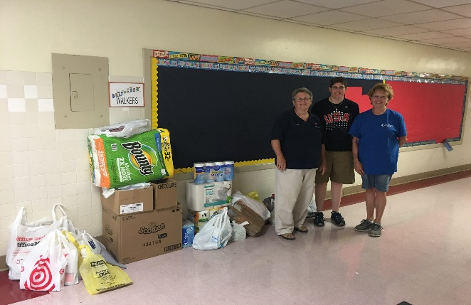

School supplies delivered to Francis Asbury teachers.

Picture courtesy of Jan Spencer

Vacation Bible School Pictures courtesy of Tracy Andrus
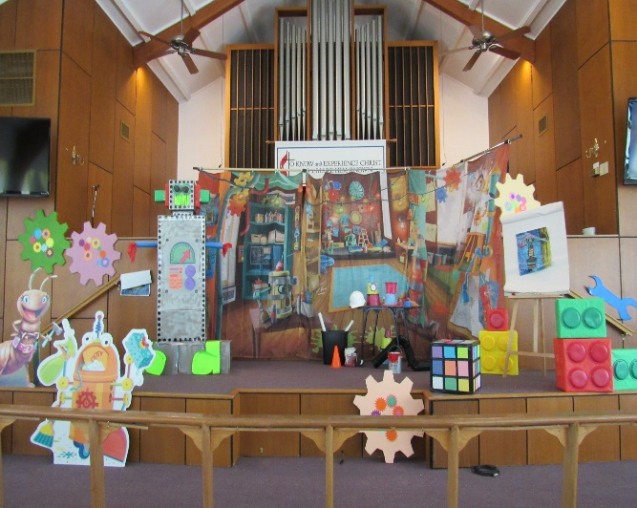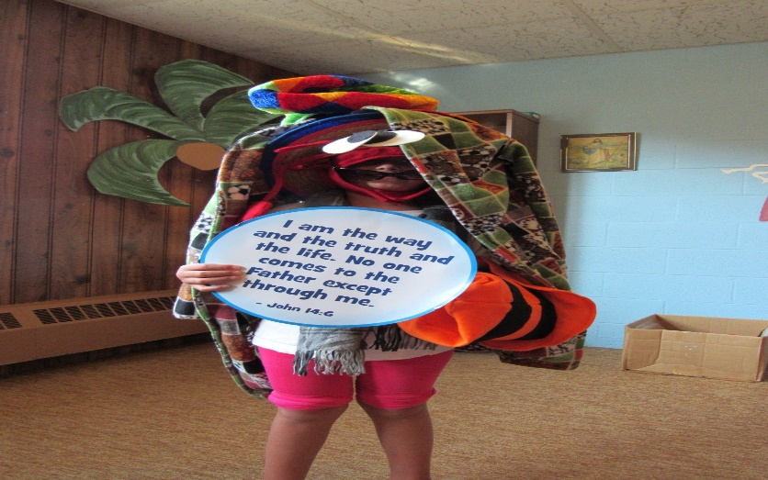

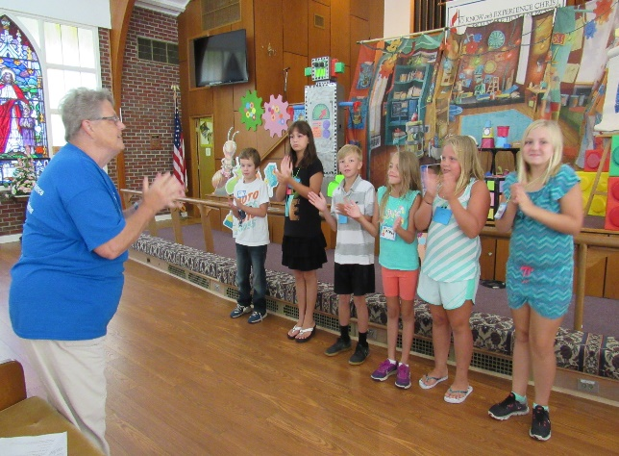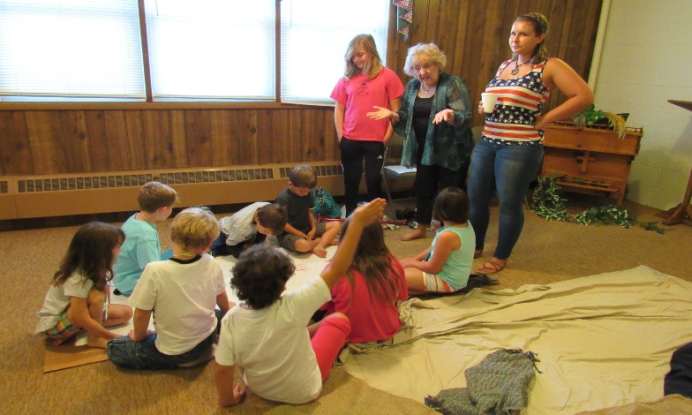

6

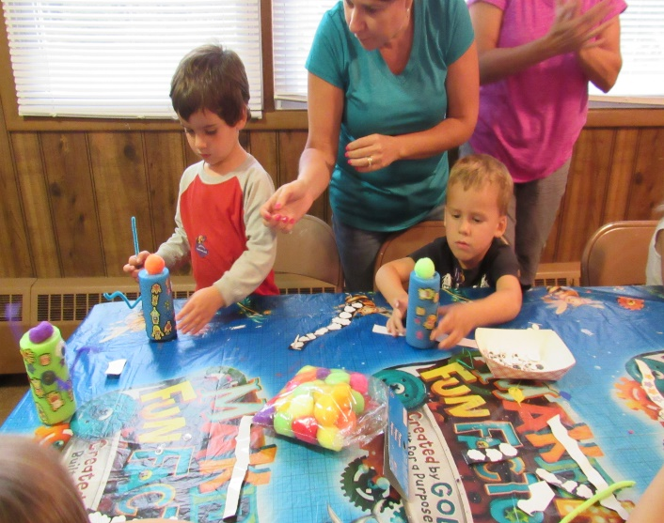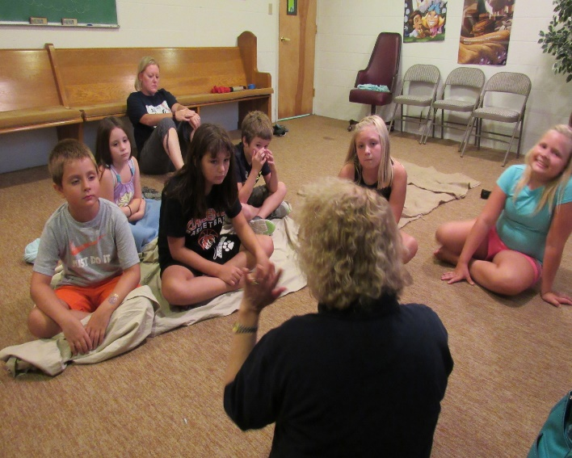

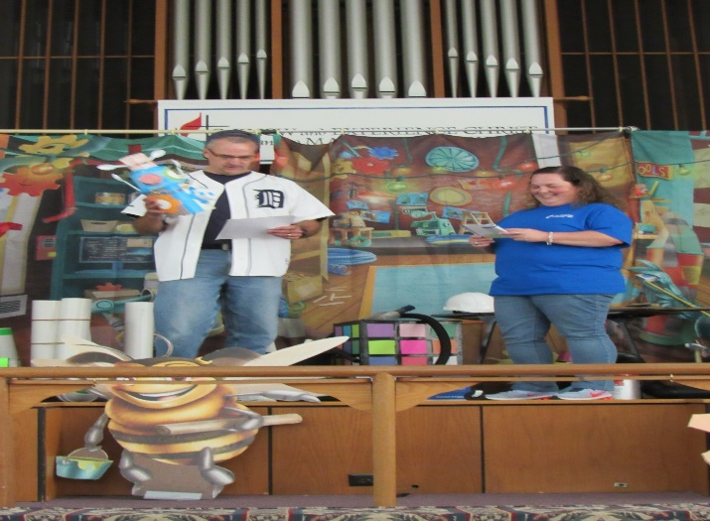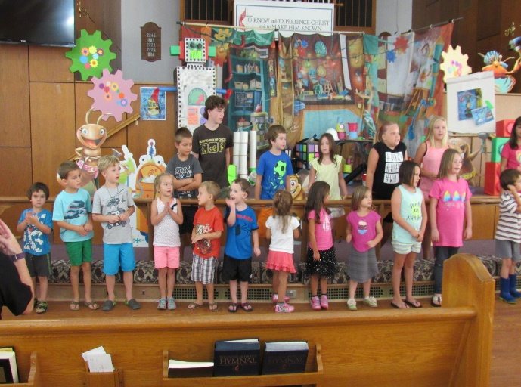

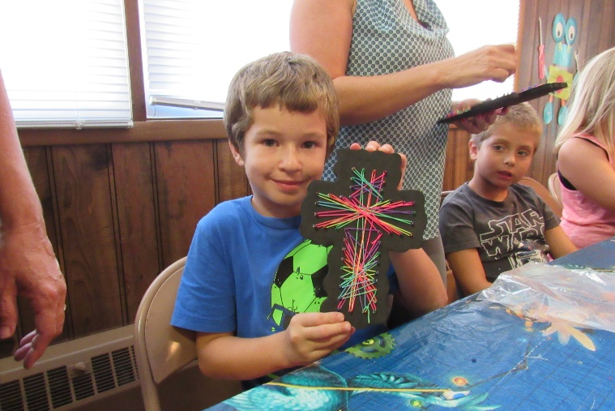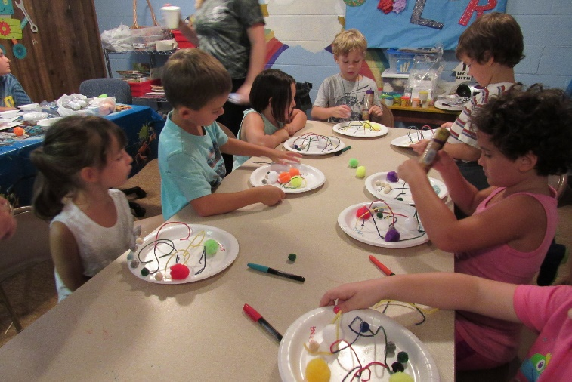

7

SEPTEMBER BIRTHDAYS
Katherine K. Glass September 4
Jo Cash September 7
Juliabeth Spencer September 10
Liv Whiting September 10
Scott Breeden, Jr. September 12
Tim Powell September 14
Missy Barrickman September 16
Amber Wallace September 24
Kathy Routten Stuewe September 25

SEPTEMBER LAY LEADERS
September 3 Ushers Rod Johnson Butch Kilmon
John Fowler Tom Cooke
Greeter Trevoe Alston
Communion Ushers Pete Raines, P.J. Routten

September 10 Ushers P.J. Routten Tommy Evans
Neal Forbes Orson Duhe
Greeters Eddie and Linda Melson

September 17 Ushers Nancy Johnson Carol Hudgins
Alann Hudson Debbie Andrus
Greeters Butch and Penny Sheffler

September 24 Ushers Eddie Melson George Black
Freddie Rowe John Brehm
Greeters P.J. and Wanda Routten

Bell Ringer: Butch Kilmon Usher for Back Door: Freddie Rowe, Tommy Evans

SEPTEMBER FLOWER CALENDAR
September 3, None The Flower Calendar is posted on the Bulletin Board. If you
September 10, Sammie Duhe would like to place flowers in church for a special occasion
September 17, None please check the calendar and write your name in the
September 24, Roscopf appropriate block. Thanks

8
SEPTEMBER 2017 CALENDAR
Sunday | Monday | Tuesday | Wednesday | Thursday | Friday | Saturday
NOTE - Sunday Services
8:30 AM - Rise and Shine Service
9:45 AM - Sunday School
11:00 AM - Morning Worship Service
5:00 PM - Youth
 |  |  |  |  | 1  7 PM - Friday Night Bible Study -Debbie Bessette | 2 |  | 24 | 25  10:00AM Bread of Life
3  See Note for  service times | 4 | 5  First Day of School  7 PM - Nominations & Leadership Development Committee Meeting | 6  10 AM - Bible Study  7 PM - Choir Practice | 7  7 PM - Joyful Women of Faith | 8  7 PM - Friday Night Bible Study – Alann Hudson | 9  2 PM -  Fox Hill  Historical  Society
10  See Note for  service times | 11  615 PM - Finance  7 PM - Admin Council | 12  730 PM - Jean Raines Circle | 13  10 AM - Bible Study  7 PM - Choir Practice | 14 | 15  7 P M - Friday Night Bible Study - Trevoe Alston | 16  630 PM - Movie Night
17  See Note for  service times | 18 | 19 | 20  10 AM - Bible Study  7 PM - Choir Practice | 21  7 PM Joyful Women of Faith | 22  7 PM - Friday Night Bible Study - Gayle Joplin | 23  1030 AM  Bread of Life
24  See Note for  service times | 25  Dinner Buddies | 26 | 27  10 AM - Bible Study  7 PM - Choir Practice | 28 | 29 | 30

9
Fox Hill Central UMC
501 Beach Road
Hampton VA 23664

Return Service Requested

The WORD, September 2017

Fox Hill Central United Methodist Church Church E-mail - fhcumc@gmail.com
501 Beach Road Pastor E-mail - ericvaudt@vaumc.org
Hampton VA 23664 Office Hours: Monday - Thursday
(757) 851-2040 9:00 AM - 1:00 PM

Pastor Eric J. Vaudt, Cell (757) 759-7484
Administrative Assistant: Carole Anne Pabst
Music Director: Ralph Snowden
Custodian: Donna Coburn
Nursery: Cheryl McCrary and Rosemarie Kidd

10

