THE WORD
Fox Hill Central United Methodist Church
Pastor Eric Vaudt August 2019

MISSION STATEMENT
To Know and Experience Christ and to make him known.

VISION STATEMENT - To encourage and strengthen our church family to be proactively engaged in ministry
as the hands and feet of Christ within Fox Hill and beyond. We embrace human needs through intentional
worship, a passionate prayer life, faithful participation in Bible study, active witnessing, individual and small
group discipleship and Christian love.

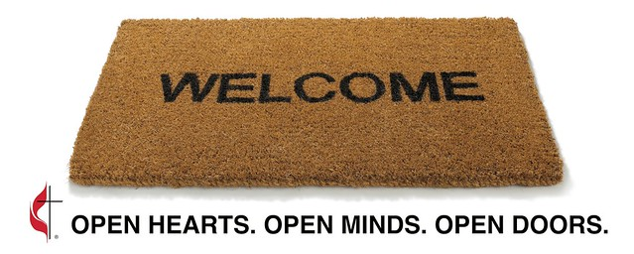

Fox Hill Central United Methodist Church E-mail - fhcumc@gmail.com
501 Beach Road Pastor E-mail - ericvaudt@vaumc.org
Hampton VA 23664 Office Hours - Monday - Thursday
(757) 851-2040 9 AM to 1 PM

Pastor Eric J. Vaudt, Cell (757) 759-7484 From the Pastor’s Desk - Page 2
Administrative Assistant: Carole Anne Pabst Prayer Concerns and Bible Studies - Page 3
Music Director: Susan Heely What’s Happening at FHCUMC - Pages 4-6
Custodian: Donna Coburn Pictures - Pages 7-8
Nursery: Cheryl McCrary and Rosemarie Kidd Birthdays, Flowers, Lay Leaders - Page 9
Calendar - Page 10

AUGUST 2019 Early in her tenure as our episcopal leader, Bishop Lewis prayerfully discerned her vision for the Virginia Annual Conference: disciples are lifelong learners who influence others to serve. As she serves in this capacity as our bishop, she is letting that vision guide her ministry. As I write this article for August, I am halfway through a sermon series called Living as Disciples, and I have to ask: ARE we living as disciples?
Being a disciple is not something one idly does: it is a WAY of living. Being a disciple is about following Jesus and living our lives in a way that exemplifies who Jesus is in our life, with the hope that Christ in us begins to shine through our humanity and attract those who have yet to hear the gospel message of Christ crucified and resurrected for the sake of redeeming love and eternal life.
The United Methodist hymnal has a relatively new hymn in it (written in 1982) called “How Shall They Hear the Word of God?” and the third verse of this hymn speaks to the above dilemma: “How shall the gospel be proclaimed that sinners may repent? How shall the world find peace at last if heralds are not sent? So send us, Lord, for we rejoice to speak of Christ with life and voice.” This is the work of a disciple, yet (here comes the hammer!) many in the Church today are merely pew warmers or members. There is a difference between members and disciples and one side (members) heavily outweighs the other (disciples). Equilibrium is far away and may never be achieved, much less tipping the scales in the other direction.
Lately I’ve been thinking back to the night I was ordained and the words Bishop Lewis spoke to me and my fellow elders-to-be that evening: “Take authority as an elder to preach the Word of God, to administer the Holy Sacraments and to order the life of the church in the name of the Father, and of the Son and of the Holy Spirit. Amen.” If you thought being a Christian, or a disciple, is a tough road, what about the life of an elder in the United Methodist Church? And it gets tougher for elders when there are no disciples to lead in ministry. I can’t/won’t/don’t-have-a-desire to do ministry myself. It takes clergy AND laity working together to be effective in ministry; to bear fruit for the kingdom of God; to make disciples of Jesus Christ for the transformation of the world. We cannot afford to shirk our role as disciples because we deem something too hard to do. Haven’t we overcome others things despite them being too hard?
Ask the question of yourself: am I a disciple, one who is a life-long learner who influences others to serve? THAT is the task of a disciple of Jesus. The work is tough, the road is long and there is a very good chance of pushback, retaliation, or that no one will respond. We may not even see the fruit of our work, but how will we know unless we try? The reward, however, is a crown of glory when God calls us home. But for now, we should be bearing the fruit of our repentance (Matthew 3:8), which is to say the work we do is evidence that we have right standing with God.
“Dear friends, do you think you’ll get anywhere in this if you learn all the right words but never do anything? Does merely talking about faith indicate that a person really has it? For instance, you come upon an old friend dressed in rags and half-starved and say, “Good morning, friend! Be clothed in Christ! Be filled with the Holy Spirit!” and walk off without providing so much as a coat or a cup of soup—where does that get you? Isn’t it obvious that God-talk without God-acts is outrageous nonsense?” (James 2:14-17, The Message)
I hope, then, that this word from Proverbs will guide us as, TOGETHER, we work to make disciples, to become life-long learners who influence others to serve: “As iron sharpens iron, so one person sharpens another.” (27:7)
Pastor Eric
2

PRAYER CONCERNS

Military Members: Robbie Bessette, Daniel Roederer, Kaitlyn Ellis, Austin Mason, Parker Wesson, Predist Walker, Colton Whiting, Mathew Smith, Quintin Mason and Michael Fain

Community: Rosella Johnson, Libby Wilson, Gene Aliff, Stacy Chambers, George Black, Peggy Conner, George Terry, Gary Coats, Judy Riss, Pat and Skippy Cole, Gail Cozzens, Mildred Lewis, Charlie Compton, Gloria Case, Kevin Jenkins, Robert Collie, Earl Parker, Gladys Allerton, Judy Burke, Jamison Dellinger, Betty Evans, Gloria Lawson (Ragsdale), and Frank Critzer

Assisted Living and Nursing Home:
Helen Williams is in North Hampton Convalescent Center.
Marian Elliott, Seton Manor, 215 Marcella Rd, Apartment 612, Hampton VA 23666 851-1762

The Shepherds visit with our home-bound members, if interested contact Jan Spencer at (757) 871-8406.

Friday Night Bible Study. Join us on Friday nights at 7 PM with Sam Joplin teaching God's word. There will be a time of praise, prayer, Bible study and fellowship. Locations TBA. All are welcome!

Wednesday Morning Bible Study meet every Wednesday at 10 AM at the church.

Joyful Women of Faith meet the 1 and 3 Thursday of each month at 7 PM at the church. All are welcome.

SYMPATHY
The pastor and congregation of Fox Hill Central UMC extend our deepest sympathy to the Raines Family on the passing of Mr. Pete Raines.

JOSH STATON is looking for odd jobs. Josh can be reached at 813-296-2739.

3

WHAT'S HAPPENING AT FOX HILL
CENTRAL UNITED METHODIST CHURCH

SAFETY AND SECURITY PROGRAM. A copy of the program has been posted on the bulletin boards and on the church website. A door bell has been installed by the back door to be used during office hours (Monday - Thursday,
9 AM to 1 PM). Questions, concerns, or to volunteer to be a security monitor contact Charlie Wallace.

ADMINISTRATIVE COUNCIL AND FINANCE COMMITTEE. It was voted at the last meeting on July 8 that going forward both the Administrative Council and Finance Committee will be meeting every other month. The next meeting for both will be September 9. Tracy Andrus

FOX HILL HISTORICAL SOCIETY meeting will be Saturday, August 10, 2 PM, at Fox Hill
Central UMC.

THE BOOK CLUB - The next book will be Any Dream Will Do by Debbie MA comber. Next meeting will be August 29, 7 PM at the church. Everyone welcome, come join us!

JEAN RAINES CIRCLE will meet on August 13 at 730 PM at the church.

BREAD OF LIFE - Come join us on Saturday, August 24 at 1030 AM. Bread of Life needs Tee Shirts. If you would like to make a monetary gift to Bread of Life see Lu Peterson, 933-3689.

STEWARDSHIP - If there is a need for monthly work days in our community or church please contact Alann Hudson
at 851-9060.

FRANCIS ASBURY ELEMENTARY SCHOOL
Box Top$ For Education - The collection container is in the Social Hall.
Plastic Bags – Don't forget to save your bags this summer. Donation boxes will be back out in the fall.

FOOD LION GIFT CARDS. We are still collecting Food Lion Gift Cards ($25) for the summer. This is the time of year they seem to be needed most. These are for our neighbors, so please, give generously. Turn them in to Jan or Alann

DEADLINE for articles and pictures for the September 2019 issue of The WORD will be August 25. Any changes, additions, deletions to Birthday List please forward to either Carole Anne (851-2040) or Ruth (851-2836).

If there are ideas or items that you would like to see included in The WORD, please let me know. Thanks Ruth

4

AUDIO VISUAL. DVDs of Sunday 11 AM services are available for our home-bound members or those hospitalized. A portable DVD unit is also available. Donations are always welcomed for this ministry. See Walter Spencer

SOCIAL MEDIA - If there is a need to get something uploaded to social media, please contact Tracy Andrus (traysea1976@gmail.com) for the church Facebook page and Sarah Woolsey (raroh2003@yahoo.com) for Facebook and the church website.

SCHOOL AND HEALTH KITS. School supplies are on sale now. Items needed for kits are shown below:

School Kits
100 - scissors (round tips, no plastic scissors)
100 – 24-count box crayons (only 24 count accepted)
300 - one-subject notebooks (no marble composition books and no 3 or 5-subject notebooks)
100 - pencil sharpener (hand held, 1-inch or longer, remove from packaging)
100 - rulers (12 inches or 30 centimeters long, sturdy or flexible material accepted)
100 - erasers (2 inches or larger)
600 - unsharpened pencils (6 pencils per kit)
100 packs - 150 sheet loose-leaf paper (either college or wide ruled) (100-200 page packets are acceptable)
100 - 2-gallon re-sealable bags

Health Kits
100 - hand towels
100 - wash cloths
100 - combs
100 - toe nail clippers
100 - bath size bars of soap
100 - toothbrushes (no toothpaste)
1000 - bandages
100 - 1-gallon re-sealable bags

Always check sales and clearance for everything. Walmart, Big/Odd Lots, Office Depot, Ollies, Roses all have great sales for school supplies. Thank you. Lu Peterson (933-3689)

Hope everyone has had a great summer filled with an abundance of great family memories.

5

Any articles for this section forward to my email. Thanks Ruth

If yu are unsure of what can be recycled, Hampton has a Curbside
Recyling Guide on the city website under Puiblic Works.
6

PICTURES COURTESY OF JAN SPENCER AND TRACY ANDRUS
Vacation Bible School at Community Presbyterian Church

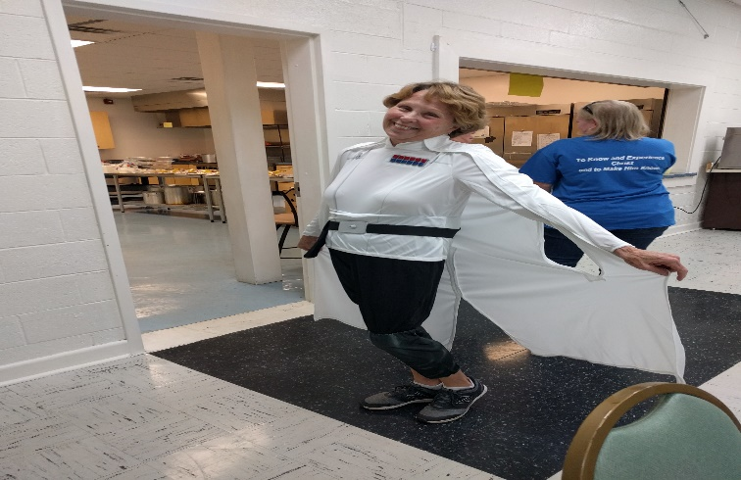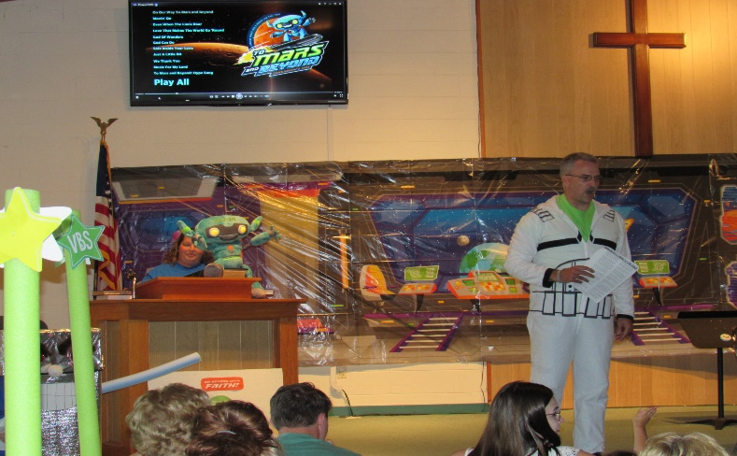

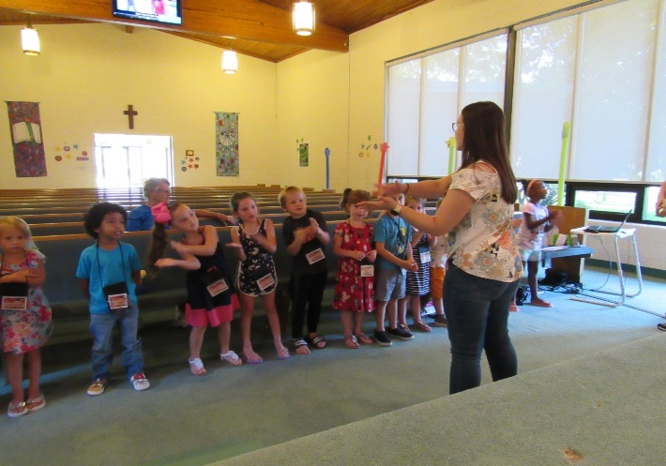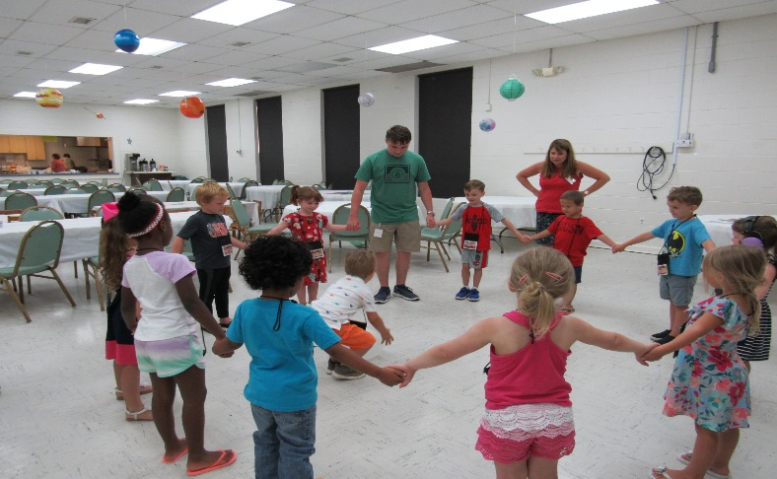

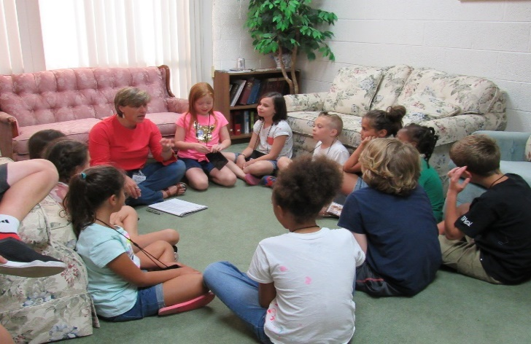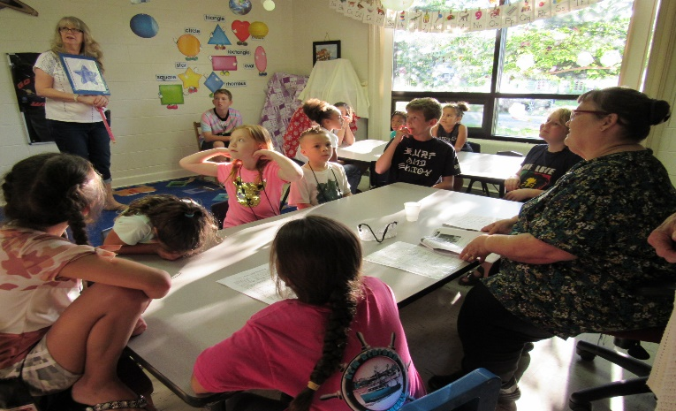

7

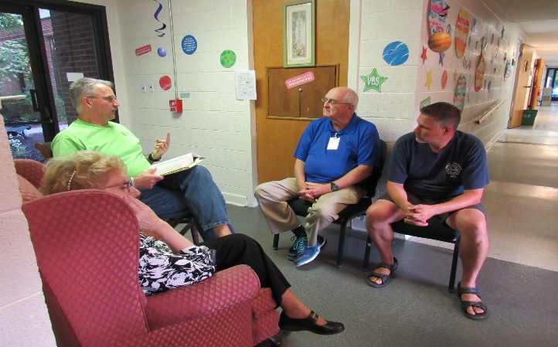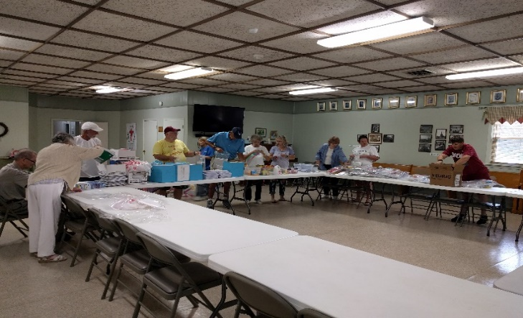
VBS Preparing Kits for Conference
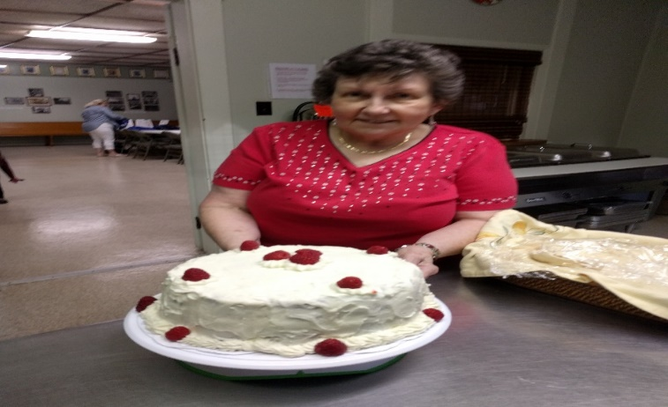
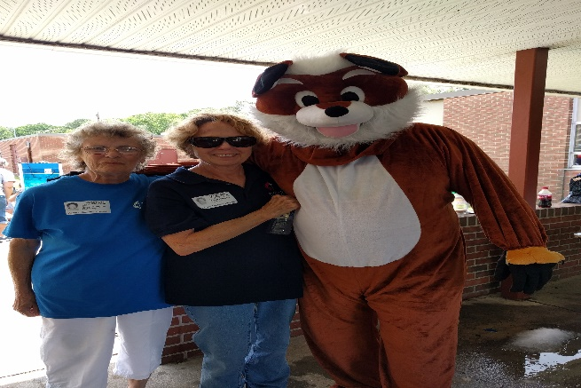
Last choir practice party Carol and Alann at Francis Asbury
Thanks for the cake, Earline

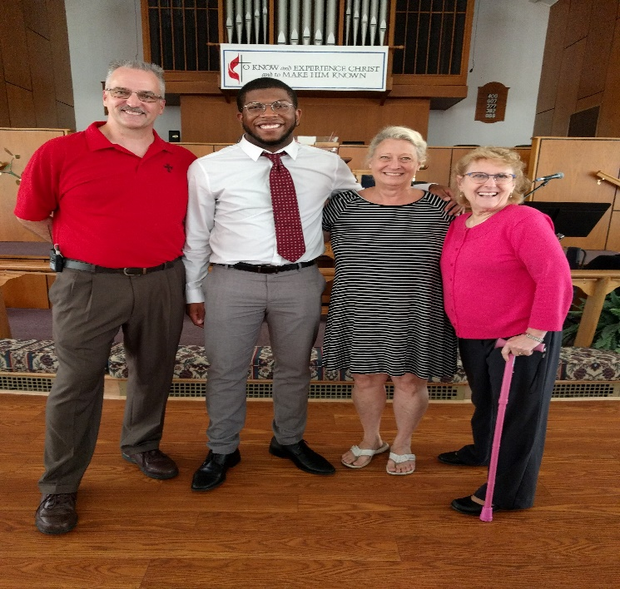

Pastor Eric, Peggy, and Susan with
Guest singer Raiquan Thomas on
July 14

8

AUGUST 2019 BIRTHDAYS

Chris Ames August 1
Debbie Andrus August 5
Brandon Burrell August 5
Linda Melson August 6
Mallory Bailey August 7
Rick Routten August 9
Dan Wesson August 11
Freddie Rowe August 12
Michael Melson August 13
Ben Franklin August 17
Tommy Evans August 18
Mary Lou Roaseau August 27
Rod Johnson August 28

AUGUST 2019 FLOWER CALENDAR
August 4, Tracy Andrus The Flower Calendar is posted on the Bulletin Board. If you
August 11, Jo Cash and Raines would like to place flowers in church for a special occasion
August 18, None please check the calendar and write your name in the
August 25, Alann Hudson appropriate block. Thank you.

AUGUST 2019 LAY LEADERS
August 4 Ushers P.J. Routten Bob Lay
Neal Forbes Orson Duhe

August 11 Ushers Jake Roscopf Phil Routten
Freddie Rowe John Brehm

August 18 Ushers Jan Spencer Alann Hudson
Debbie Bessette Linda Melson

August 25 Ushers Richard Roscopf Rocky Reichenbach
Carl Wallace Charlie Wallace

Communion 1st and 3rd Sunday each month Communion Ushers - Butch Kilmon, P.J. Routten
Bell Ringer - Butch Kilmon Usher for Back Door - Freddie Rowe, Tommy Evans

9
AUGUST 2019 CALENDAR
SUNDAY | MONDAY | TUESDAY | WEDNESDAY | THURSDAY | FRIDAY | SATURDAY
WORSHIP
SCHEDULE
8:30 AM Rise & Shine Service
9:45 AM Sunday School
11 AM Morning Worship Service
 |  |  |  | 1  7 pm – Joyful Women | 2  7 PM – Friday Night Bible Study | 3
4 | 5 | 6 | 7  10 AM - Bible Study | 8 | 9  7 PM – Friday Night Bible Study | 10  2 PM – Fox Hill Historical Society
11 | 12 | 13  730 PM – Jean Raines Circle | 14  10 AM - Bible Study | 15  7 PM – Joyful Women | 16  7 PM – Friday Night Bible Study | 17
18 | 19 | 20 | 21  10 AM - Bible Study | 22 | 23  7 PM – Friday Night Bible Study | 24  1030 AM – Bread of Life
25 | 26  12 PM - Lunch Buddies | 27 | 28  10 AM - Bible Study | 29  7 PM – Book Club | 30  7 PM – Friday Night Bible Study | 31
10

