THE WORD
Fox Hill Central United Methodist Church
Pastor Eric Vaudt January 2019

MISSION STATEMENT
To Know and Experience Christ and to make him known.

During a recent vacation Peggy and I had the opportunity to worship in other United Methodist churches. The first was in Littleton, NC, just outside of Lake Gaston. As we settled into our seat I noticed another “new” couple who sat just a few seats down from us. The pastor was quick to stop by this new couple and introduce himself but, as he made his way to the other side of this section of seats where we were seated, he walked past our row and then decided to stop and say hello. I wonder why he didn’t see fit to introduce himself to us? His associate pastor just stood by the piano talking with those who came up to her. As far as the second church we visited, it was a church on the district and their greetings and welcoming was reserved for the inner circle, not for outsiders as we clearly were.
Dr. Amy Oden is the former Professor of Church History at Wesley Theological Seminary in Washington D.C. and not too long ago she published a book on hospitality titled And You Welcomed Me. In this book she says that “both the Old and New testaments identify a duty of hospitality,” listing Genesis 18:4, 19:7, Judges 19:20, Matthew 10:40-41 and Romans 12:13 as scriptural references. Hebrews 13:2 is also another excellent reason why we should show hospitality “to strangers,” or visitors. On the signature line of my outgoing e-mail I used to use a quote from St. Benedict that says, “All guests who present themselves are to be welcomed as Christ, for he himself will say 'I was a stranger and you welcomed me.” Hospitality is important in the life of the church, especially if we want the church to grow. If hospitality is lacking, then growth will stall and membership will begin to decline. I have to wonder how many churches are in a state of decline but do not recognize the factors that might be leading to that decline, especially if they are not a welcoming congregation? If we are inward-focused and not outward-focused in mission and ministry, then we are not focused on welcoming the stranger into our presence and to not welcome a stranger, or a visitor, is to not welcome the very presence of Christ.
So as we once again begin a new year together, my prayer will be that we will look upon “our neighbor” as the very presence of Christ in our midst because we were all made in the image of God. My hope is that as we gather for worship each week that we will take a look at who is worshipping with us, and that we will make an attempt to welcome all who join with us in worshipping the God of love and peace, whether they are a familiar face or a one-time visitor. If I’m ever in Littleton again, I may, or may not, return to Littleton UMC. Would you? And if you’re curious about the scripture passage St. Benedict used for that particular quote, read Matthew 25:31-46.
May God’s grace be in abundance in 2019, upon each one of us, as we work to make disciples of Christ for the transformation of the world; and may that grace help us to share the love of God and the light of Christ with all of humanity, so that all of humanity may feel the Spirit of peace.
Pastor Eric

VISION STATEMENT - To encourage and strengthen our church family to be proactively engaged in ministry
as the hands and feet of Christ within Fox Hill and beyond. We embrace human needs through intentional
worship, a passionate prayer life, faithful participation in Bible study, active witnessing, individual and small
group discipleship and Christian love.

This was shared by Kathy Wallace. It's worth sharing again. Let us make one of our New Year's Resolutions to attend church regularly in 2019. We did vow to uphold our church with our prayers, PRESENCE, gifts, service and witness. Jan Spencer

"In order to make it possible for everyone to attend church this week, we are planning a 'NO EXCUSE' Sunday!
Cots will be placed in the foyer for those who say, 'Sunday is my only day for sleeping in.'
Eye drops will be available for those whose eyes are tired from watching TV too late on Saturday night.
Blankets will be furnished for those who think the church is too cold.
Fans will be on hand for those who say the church is too hot.
We will have hearing aids for the parishioners who say, 'The priest doesn't talk loud enough.'
There will be cotton for those who say, 'The priest talks too loud.'
Score cards will be available for those who wish to keep track of the hypocrites.
We guarantee that some relatives will be present for those who like to go visiting on Sunday.
There will be TV dinners available for those who claim they can't go to church and cook dinner too.
One section of the church will have some trees and grass for those who see God in nature, especially on the golf course.
The sanctuary will be decorated with both Christmas poinsettias and Easter lilies to create a familiar environment for those who have never seen the church without them.
by R.E.Kidbits

2
PRAYER CONCERNS
Military Members: Robbie Bessette, Daniel Roederer, Kaitlyn Ellis, Austin Mason, Parker Wesson, Predist Walker, Colton Whiting, Mathew Smith, and Quintin Mason

Quintin Mason is currently at Boot Camp. He graduates on January 18, 1029. If you would like to send him a card, his address is: SR Mason, Quintin P.
Ship 06 DIV 078,
3510 Illinois St
Great Lakes IL 60088-3119

Community: Rosella Johnson, Libby Wilson, Gene Aliff, Stacy Chambers, George Black, Peggy Conner, Pete Raines, George Terry, Gary Coats, Judy Riss, Pat and Skippy Cole, Gail Cozzens, Mildred Lewis, Elizabeth Dwiggins, Charlie Compton, Gloria Case, Susan Heely, and Dennis Vaughn

Assisted Living and Nursing Home:
Helen Williams is in North Hampton Convalescent Center.
Marian Elliott, Seton Manor, 215 Marcella Rd, Apartment 612, Hampton VA 23666 851-1762

Extending the Table is conducted under the rites of the United Methodist Church, endorsed by the Administrative Board of Fox Hill Central, and under the supervision of Rev Eric Vaudt. The Shepherds have made this part of their ministry as they visit those who are unable to come to church and participate in our Lord’s Supper. Visits are scheduled for the first of each month. If you know of someone who is in need of this ministry please call the church office at 851-2040.

Shepherds - If you are interested in visiting our members who are house-bound, please consider the Shepherds. Qualifications - you need to be available to visit for an hour or so one-time a month (your choice of day or evening) and you need to be willing to make conversation. As our congregation ages, more and more of our folks are finding that getting to church every Sunday is more difficult, even impossible. Yet, they want to hear from, and remain involved in, THEIR church. Please contact Jan Spencer at 871-8406 if you are interested in joining the Shepherds.

REMINDERS
The 2019 offering envelopes are available in the Narthex. If you do not see yours please contact the office.

Creation Care Day will be Saturday, April 13, 2019. We need to start thinking about what can be re-purposed into a craft. Seed starting is usually in February and March. Any ideas, give me a call. Thanks Jan Spencer, 871-8406

SYMPATHY
The pastor and congregation of Fox Hill Central United Methodist Church extend sympathy to:
Carol and Liv Whiting on the death of Carol's sister Anne Rakes. Anne passed away December 4.

Marjorie and Neal Forbes on the death of Marjorie's mother Nancy, who passed away on December 26.

3
WHAT’S HAPPENING AT FOX HILL CENTRAL UNITED METHODIST CHURCH

FOX HILL HISTORICAL SOCIETY meeting will be Saturday, January 12 at 2 PM, at Fox Hill
Central UMC.

THE BOOK CLUB - The next book will be A Life Intercepted by Charles Martin. Next meeting will be January 24, 2019. Everyone welcome, come join us!

JEAN RAINES CIRCLE - will not meet during January and February 2019.

YOUTH - next meeting TBA.

BREAD OF LIFE - Come join us on Saturday, January 26 at 1030 AM. Bread of Life needs men's and women's jeans, men's shoes, and men's and women's winter clothes. Lu Peterson, 933-3689

STEWARDSHIP will not be doing monthly work days in our church and community until the weather gets better.
If a need does come up please contact Alann Hudson at 851-9060.

YOGA CLASS - During winter, the Yoga Class will meet only on Mondays at 10 AM. If you are interested, please contact Rachel at 773-701-8729.

FOLDED FABRIC FELLOWSHIP - On Saturday, February 2 from 930 to 1130 AM I will host a "Folded Fabric Fellowship" time for anyone who wants to get together and make cathedral windows and/or ornaments using scrap fabric pieces. If you want to learn, please come…if you know how and just want to share scraps, please come. We can share coffee, Danish, fabric, and other ideas. You will need scissors, needle, thread (ecru), scrap pieces if you have them, and dressmaker straight pins. For further information or to RSVP, call Jan Spencer at 871-8406.

4
Friday Night Bible Study. Sam Joplin is teaching on Philippians. There will be a time of praise, prayer, Bible study and fellowship. All are welcome!
January 4, TBA
January 11, TBA
January 18, Trevoe Alston, 920-9751
January 25, Gayle Joplin, 851-4650

Wednesday Morning Bible Study meet every Wednesday at 10 AM at the church.

Joyful Women of Faith meet the 1 and 3 Thursday of each month at 7 PM at the church.
All are welcome.

Any articles for this section forward to my email. Thanks Ruth

If you are unsure of what can be recycled, Hampton has a Curbside
Recycling Guide on the city website under Public Works.

ITEMS NEEDED FOR KITS -Thank you Fox Hill Congregation. With your help we can get this done. If you wish to donate cash, please give it to Alann Hudson. Again, Thank you. Lu Peterson
10 pencil sharpeners 50 bars of soap
50 rulers 70 hand towels
55 scissors 70 wash clothes
10 crayons 100 finger nail clippers
30 sprial notebooks (one subject) 50 tooth brushes
170 bandaids
70 combs
90 2-gallon bags

FRANCIS ASBURY ELEMENTARY SCHOOL - Box Top$ For Education - The collection container is in the Social Hall. Plastic Bags - Donation boxes located in Sunday School Wing and by Back Door.

THANK YOU - Thank you to everyone who gave so generously in our show of appreciation to the First Responders at Fox Hill Fire Station. A total of $500.00 in cash and gift cards was collected from Fox Hill Central. The total donations from the community was $2300.00! What a wonderful gesture of appreciation to these who serve this community so faithfully. Those we talked to at the station on Christmas Eve were touched, not just by the generosity, but by the support and thoughtfulness shown them year round. Please pray for all First Responders. God bless you -- Alann

DEADLINE for the February 2019 issue of The WORD will be January 24.

5
CAROLING PICTURES (Courtesy of Jan Spencer)
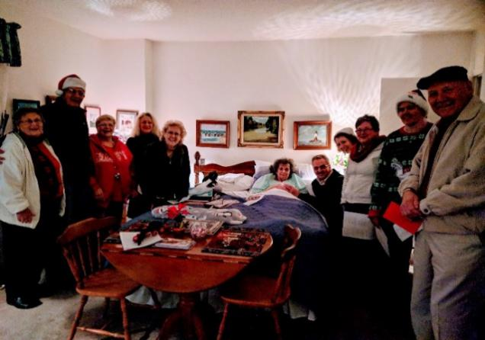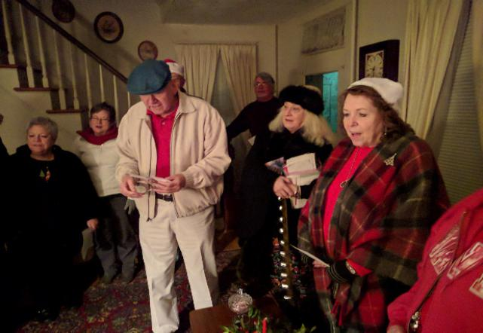
Marian Elliott Millie's Home

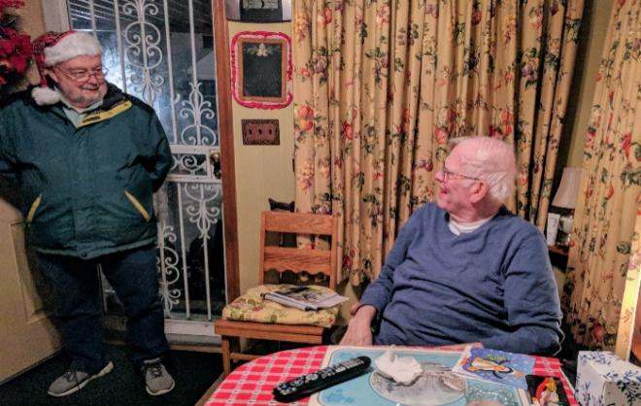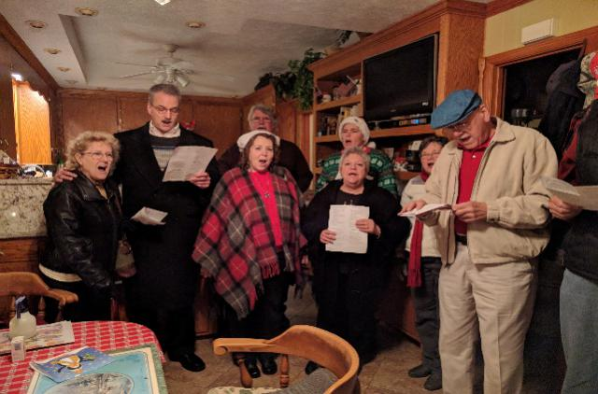
George Black

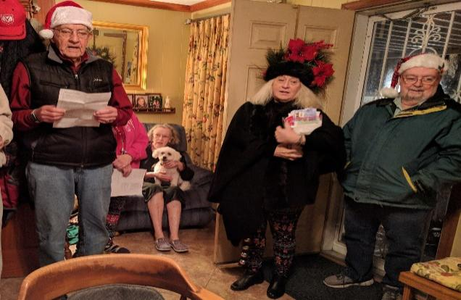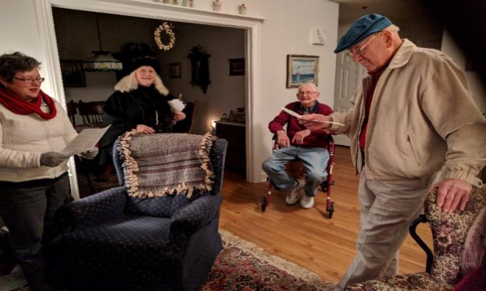
Jessie Kay and the Singing Dog Skippy Cole

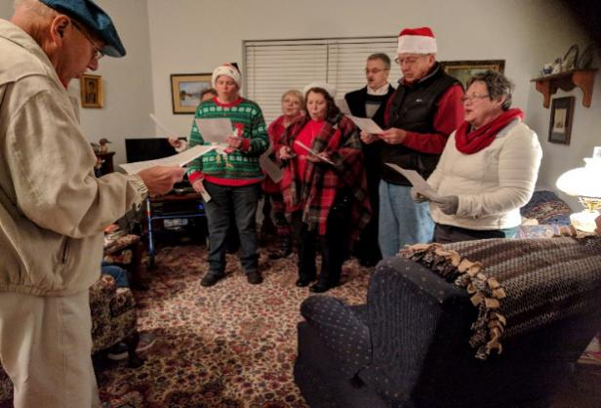 Skippy and Pat Cole Home
6
BREAD OF LIFE AND RAINBOW GIRLS FROM REGIONAL DISTRICT
(Pictures courtesy of Jan Spencer)

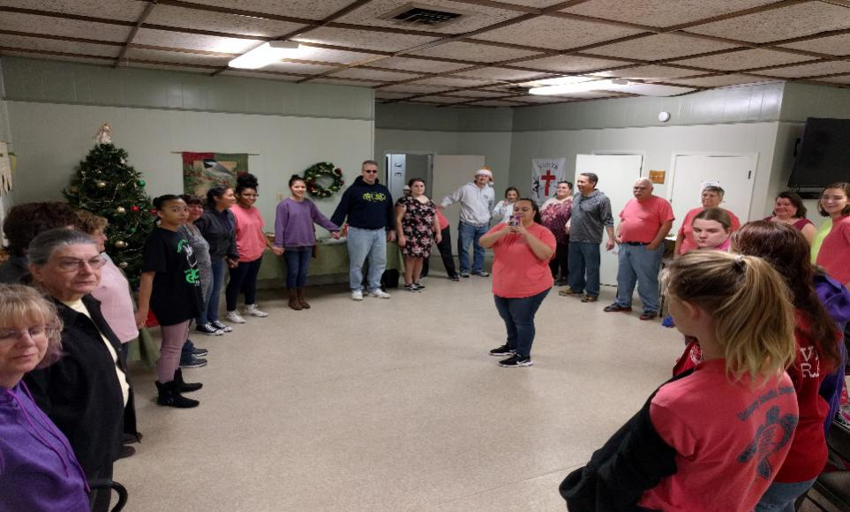

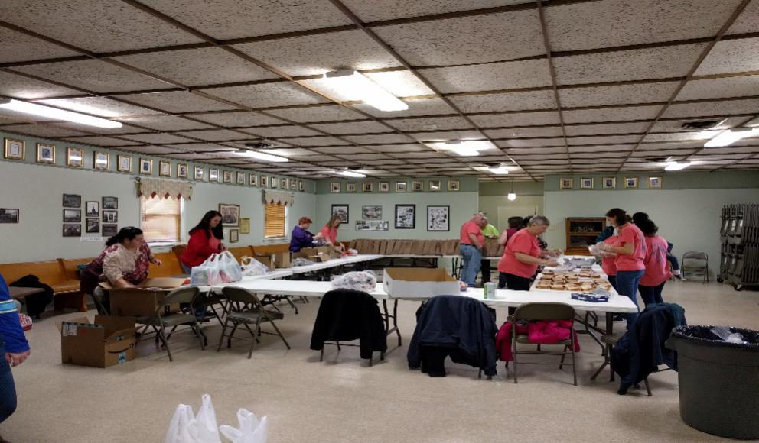

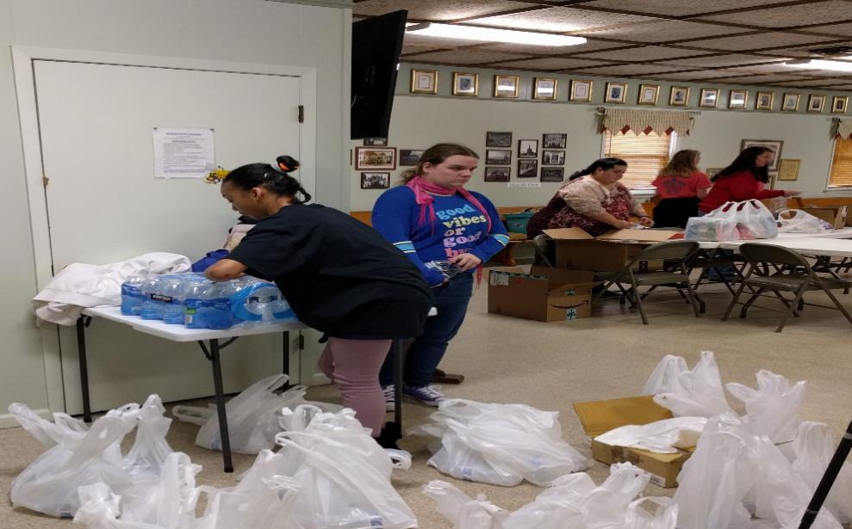
7
JANUARY 2019 BIRTHDAYS
Barbara Ritchie January 2
Kim Conner January 2
Butch Sheffler January 3
Jeannabeth Spencer January 3
Beth Spencer January 4
Michael Spencer January 4
Jessie Kay Black January 6
Makalla Routten January 12
Sear Holleran January 12
Dawson Pabst January 16
Walter Spencer January 18
Megan Wesson January 24
Autumn Barrickman January 24
Sherry Pabst Brown January 26
Kasey Powell Nelson January 28

JANUARY 2019 LAY LEADERS
January 6 Ushers Richard Roscopf Rocky Reichenbach
Carl Wallace Charlie Wallace

January 13 Ushers P.J. Routten Bob Lay
Neal Forbes Orson Duhe

January 20 Ushers Debbie Andrus Alann Hudson
Nancy Johnson Carol Hudgins

January 27 Ushers Rod Johnson Butch Kilmon
Teddy Cave Tom Cooke

Communion 1st and 3rd Sunday each month Communion Ushers Butch Kilmon, P.J. Routten

Bell Ringer: Butch Kilmon Usher for Back Door: Freddie Rowe, Tommy Evans

JANUARY 2019 FLOWER CALENDAR
January 6, Spencer The Flower Calendar is posted on the Bulletin Board. If you
January 13, Bessette would like to place flowers in church for a special occasion
January 20, Eddie & Linda Melson please check the calendar and write your name in the
January 27, None appropriate block. Thanks

8
JANUARY 2019 CALENDAR
Sunday | Monday | Tuesday | Wednesday | Thursday | Friday | Saturday
NOTE - Sunday Services
8:30 AM - Rise and Shine Service
9:45 AM - Sunday School
11:00 AM - Morning Worship Service
5:00 PM - Youth
 |  | 1  New Year's Day | 2  10 AM - Bible Study  7 PM - Choir Practice | 3  7 PM - Joyful  Women of Faith | 4  7 PM - Friday Night Bible Study -TBA | 5 |  | 24 | 25  10:00AM Bread of Life
6  See Note for  service times | 7 | 8 | 9  10 AM - Bible Study  7 PM - Choir Practice | 10 | 11  7 PM - Friday Night Bible Study - TBA | 12  2 PM - Fox Hill Historical Society
13  See Note for  service times | 14  7 PM - Administrative Council | 15 | 16  10 AM - Bible Study  7 PM - Choir Practice | 17  7 PM - Joyful Women of Faith | 18  7 P M - Friday Night Bible Study - Trevoe Alston | 19  1030 AM - Bread  of Life
20  See Note for  service times | 21 | 22  e | 23  10 AM - Bible Study  7 PM Choir Practice | 24  7 PM - Book Club | 25  7 PM - Friday Night Bible Study-  Gayle Joplin | 26
27  See Note for  service times | 28  1130 AM - Lunch Buddies  Anderson's Garden Center | 29 | 30  10 AM - Bible Study  7 PM Choir Practice | 31

9

Fox Hill Central UMC
501 Beach Road
Hampton VA 23664

Return Service Requested

The WORD, January 2019

Fox Hill Central United Methodist Church E-mail - fhcumc@gmail.com
501 Beach Road Pastor E-mail - ericvaudt@vaumc.org
Hampton VA 23664 Office Hours: Monday - Thursday
(757) 851-2040 9:00 AM - 1:00 PM

Pastor Eric J. Vaudt, Cell (757) 759-7484
Administrative Assistant: Carole Anne Pabst
Music Director: Susan Heely
Custodian: Donna Diller (Coburn)
Nursery: Cheryl McCrary and Rosemarie Kidd

10

