THE WORD
Fox Hill Central United Methodist Church
Pastor Eric Vaudt March 2019
MISSION STATEMENT
To Know and Experience Christ and to make him known.

My friends, the called General Conference of the global United Methodist Church has met in St. Louis, MO and, with some personal surprise, an amended Traditional Plan was passed by a majority vote just prior to the close of Conference on Tuesday evening, February 26, 2019. The Traditional Plan tightens restrictions against clergy presiding over same sex unions and against the ordination of openly gay persons. The One Church Plan, which would have left those decisions up to each local church, was voted down in Legislative Session and was brought to the plenary session as a minority report where it was defeated a second time. After some amendments were brought to the floor and either accepted or rejected for the Traditional Plan, the plan passed with 53% of the vote.

While I was a proponent of the Traditional Plan, I confess that I am not overjoyed by this decision because there are no clear winners in this fight over human sexuality. One thing I have NOT done is led Fox Hill Central to see the argument from the other side. Despite your opinions on human sexuality, more specifically homosexuality, this is what the Traditional Plan tells those who have varying sexual orientation: you are not welcome, we do not recognize your gifts for ministry, you are not accepted, you cannot preach. This clearly violates Jesus’ teaching in Matthew 7 and Luke 6: do to others as you would have them do to you. And so I’m asking you to put yourself on the other side of the equation, and try to imagine what it would feel like for the Church to tell you that you are not welcome because you are different.

The reason for that challenge is that we cannot gloat, we cannot celebrate and say “we won.” Right now, throughout the whole of Methodism there is hurt, there is pain and there is a lot of anger. Right now, throughout the whole of Methodism, there is also a TON of hypocrisy. Legislation was introduced to hold all clergy and bishops to every mandate of the Book of Discipline regarding human sexuality, specifically remarriage, divorce and adultery, that if any clergy person is guilty of any of these, they should lose their credentials. Matthew 5:31-32 served as a reference. That motion failed, which tells the world that those acts are acceptable; that we can look the other way and that only homosexuality is immoral.

I imagine a lot of you are going to have a lot of questions. I may have some answers for you and I may not, but I will endeavor to answer all of them. What does the Traditional Plan mean for the future of the United Methodist Church? That really remains to be seen. Right now it means that we continue to minister to our community and to share the gospel message of salvation in Jesus Christ. The United Methodist Church is once again experiencing the grip of an issue that only God understands and can solve, and we must trust that God will lead the way through this wilderness. I don’t believe the divine golden scepter was revealed at General Conference, but I do believe that our God is at work in this mess. We must continue to pray, my friends. We must continue to pray, for ALL of us were made in the image of God, and ALL of us have sinned and fallen short of God’s glory.
Pastor Eric

VISION STATEMENT - To encourage and strengthen our church family to be proactively engaged in ministry
as the hands and feet of Christ within Fox Hill and beyond. We embrace human needs through intentional
worship, a passionate prayer life, faithful participation in Bible study, active witnessing, individual and small
group discipleship and Christian love.
PRAYER CONCERNS
Military Members: Robbie Bessette, Daniel Roederer, Kaitlyn Ellis, Austin Mason, Parker Wesson, Predist Walker, Colton Whiting, Mathew Smith, Quintin Mason and Michael Fain

Community: Rosella Johnson, Libby Wilson, Gene Aliff, Stacy Chambers, George Black, Peggy Conner, Pete Raines, George Terry, Gary Coats, Judy Riss, Pat and Skippy Cole, Gail Cozzens, Mildred Lewis, Charlie Compton, Gloria Case, Kevin Jenkins, Robert Collie and Earl Parker

Assisted Living and Nursing Home:
Helen Williams is in North Hampton Convalescent Center.
Marian Elliott, Seton Manor, 215 Marcella Rd, Apartment 612, Hampton VA 23666 851-1762

The Shepherds visit with our home-bound members, if interested contact Jan Spencer at (757) 871-8406.

CONGRATULATIONS
Congratulations to Joseph Evans for being inducted into the Christopher Newport University's Athletic Hall of Fame for Golf on February 2, 2019. Well done!

UPCOMING EVENTS
April 10 – 5-7 PM – Clark Cemetery Spaghetti Dinner (See info Page 4)
April 13 – Creation Care Day (See info on Page 6)
April 21 – Easter - Sunrise Service on Easter morning will be held on the front lawn of the church. Bring a lawn chair (and maybe a lap robe.) Easter Egg Hunt will be held on the lawn immediately after worship service Easter Sunday.

5TH SUNDAY SERVICES
930 AM – Sunday School
1030 AM – Worship Service followed by Fellowship Luncheon
Please bring a meat and side dish for your family. Fried chicken will not be provided.

ASH WEDNESDAY SERVICE March 6, 7 PM, at First UMC Fox Hill, 1 Salt Pond Road.

2

DAYLIGHT SAVING TIME – Don’t forget to set your
Clocks ahead on March 10.
SPRING FORWARD

WHAT'S HAPPENING AT FOX HILL CENTRAL UNITED METHODIST CHURCH

FOX HILL HISTORICAL SOCIETY meeting will be Saturday, March 9 at 2 PM, at Fox Hill Central UMC.

THE BOOK CLUB - The next book will be Dead Don’t Dance by Charles Martin. Next meeting will be at the church, TBA in the Bulletin. Everyone welcome, come join us!

JEAN RAINES CIRCLE - will meet on March 12 at 730 PM at the church.

YOUTH - next meeting date and time TBA.

BREAD OF LIFE - Come join us on Saturday, March 23 at 1030 AM. Lu Peterson, 933-3689

STEWARDSHIP will not be doing monthly work days in our church and community until the weather gets better.
If a need does come up please contact Alann Hudson at 851-9060.

FOLDED FABRIC FELLOWSHIP will be held on Saturday, March 30
from 9:30 to 11 AM. It's fun!

FRANCIS ASBURY ELEMENTARY SCHOOL Box Top$ For Education - The collection container is in the Social Hall. Plastic Bags - Donation boxes located in Sunday School Wing and by Back Door.

TRANSPORTATION
We are updating our list of folks that would be inteerested and available to transport members of our church community
to doctor’s appointment, etc. when needed. Please contact the church office at 851-2040 if you would like to help out.

DEADLINE for articles and pictures for the April 2019 issue of The WORD will be March 24. Thanks Ruth

3

Friday Night Bible Study. Join us on Friday nights with Sam Joplin teaching God's word. There will be a time of praise, prayer, Bible study and fellowship. Locations TBA. All are welcome!

Wednesday Morning Bible Study meet every Wednesday at 10 AM at the church.

Joyful Women of Faith meet the 1 and 3 Thursday of each month at 7 PM at the church. All are welcome.

Ladies Winter Bible Study – will be studying OVERCOMER with Dr. David Jeremiah as our teacher. Our 10-week study will meet every Tuesday in March at 10 AM and 7 PM.

ITEMS NEEDED FOR KITS -Thank you Fox Hill Congregation. With your help we can get this done. We need 70 hand towels, 70 wash clothes and 100 nail clpppers. These are the hardest to collect, please consider these items when shopping. If you wish to make a donation , please give to Allan. Again, Thank you. Lu Peterson
10 pencil sharpeners 50 bars of soap
50 rulers 70 hand towels
55 scissors 70 wash clothes
10 crayons 100 finger nail clippers
30 sprial notebooks (one subject) 50 tooth brushes
170 bandaids
70 combs
90 2-gallon bags

VACATION BIBLE SCHOOL (VBS)
If anyone is interested in taking over the VBS Coordinator position, please contact Cindy Roscopf at 329-8068.

There will be a Vacation Bible School Seminar at Providence UMC (804-932-4973) on March 9, 830 AM – 1230 PM, cost $20.00. Providence UMC
4001 New Kent Highway
Quinton VA 23141

SAVE THE DATE!!
It’s Clark Cemetery Spaghetti Dinner, Wednesday, April 10, 2019, 5 to 7 PM at Fox Hill Central UMC. Help needed
In areas of set up, clean up, kitchen crew, waitressing, baking cakes. . . . .
If you can assist in any of these areas, please contact Katie Arredondo at 927-3631. Thank you for your support!

4

5

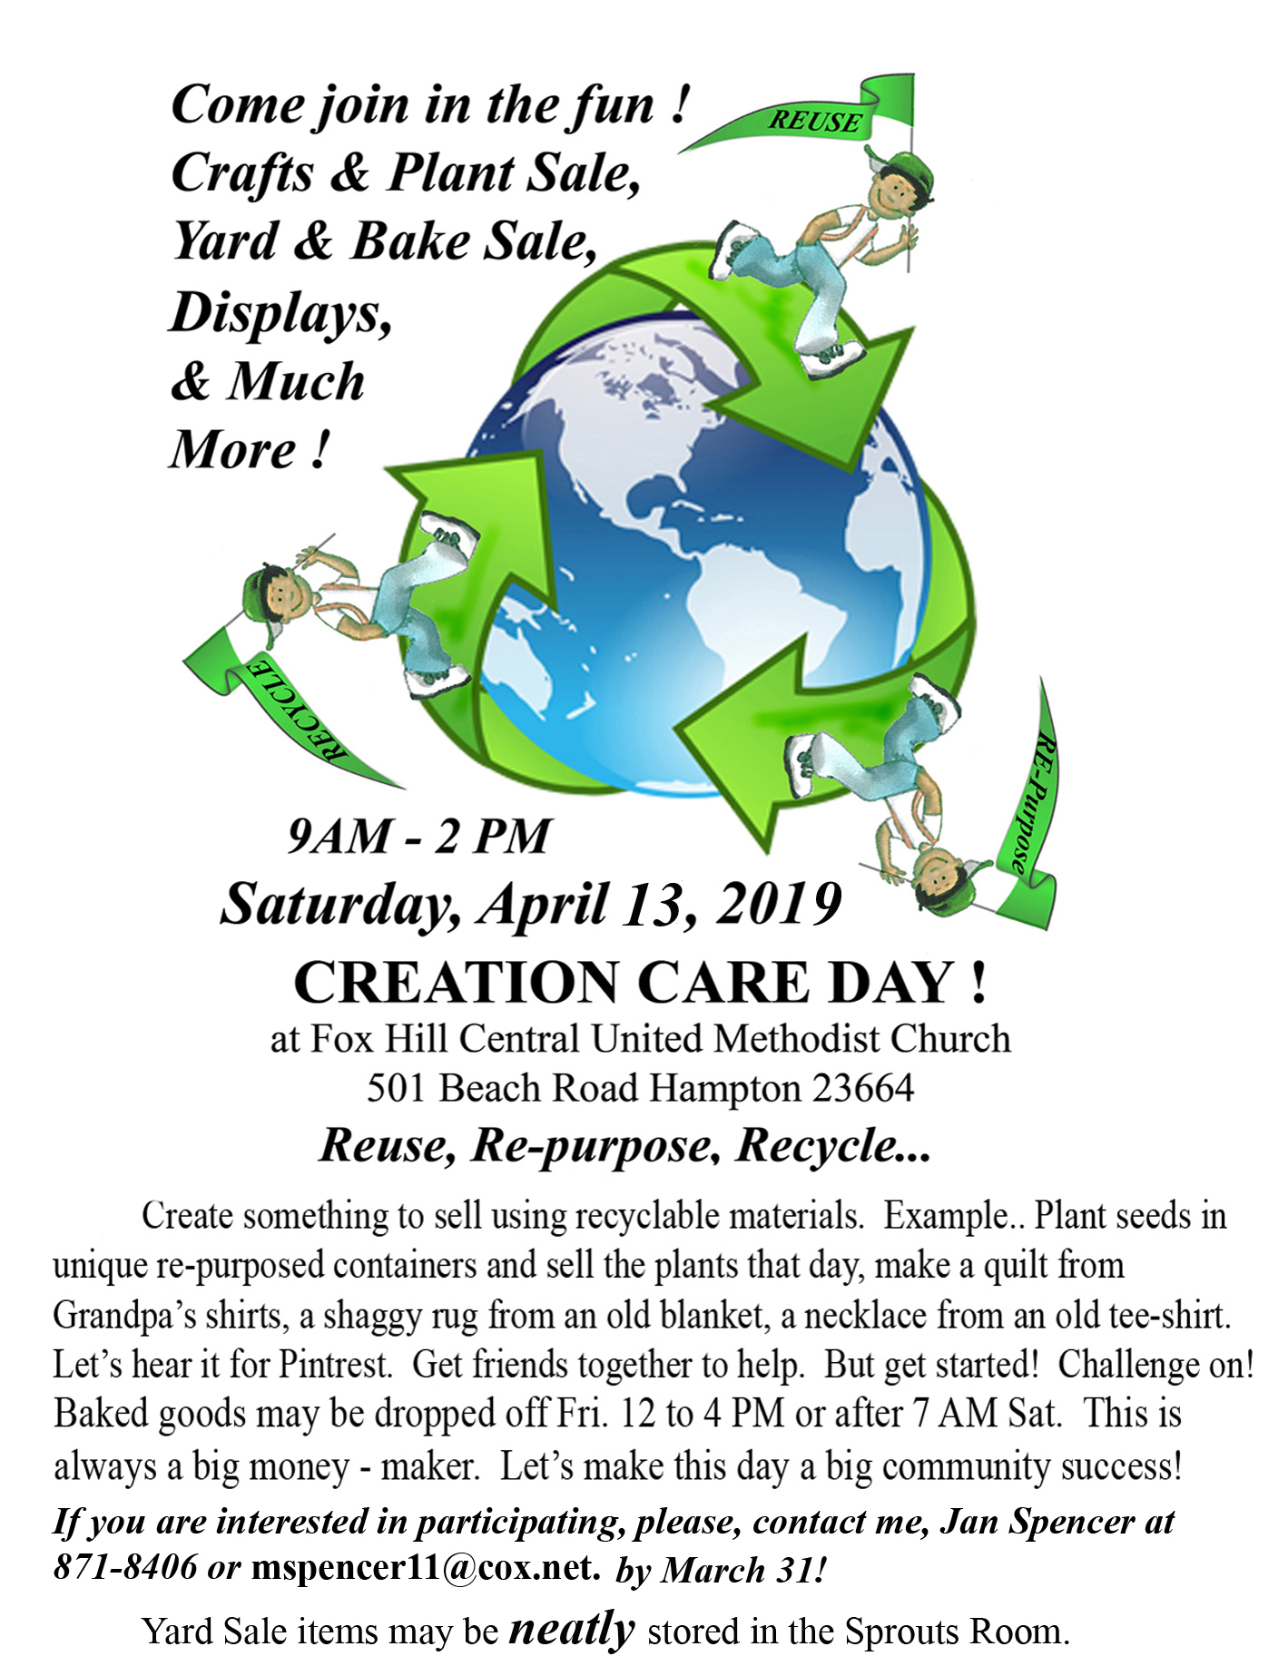
6

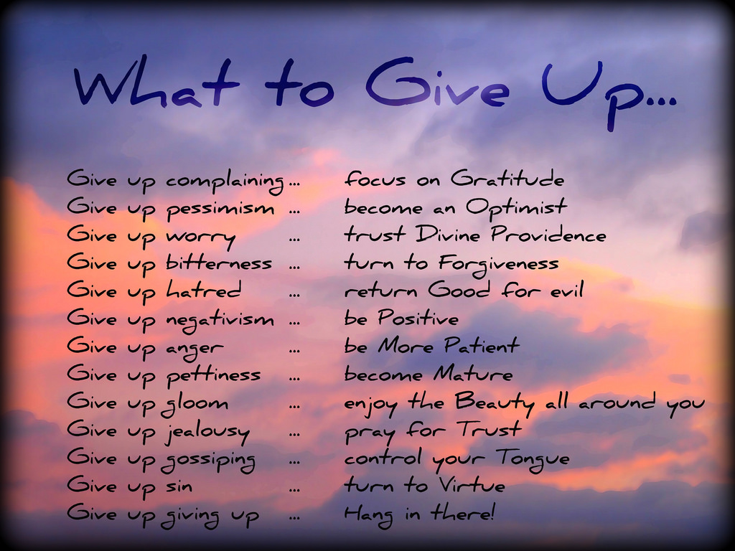

Any articles for this section forward to my email. Thanks Ruth

If you are unsure of what can be recycled, Hampton has a Curbside
Recycling Guide on the city website under Public Works.

7
MARCH 2019 BIRTHDAYS
Caleb Spencer March 4
Grady Wesson March 6
Sam Joplin March 8
Mason Holleran March 12
Peggy Vaudt March 14
Alann Hudson March 15
Owen Roederer March 19
Mark Spencer March 24
Dusty Wallace March 27
Sadye Barrickman March 28
Betsy Griffith March 29
Lindsey Bethel March 29
Lou Lay March 29
Michelle Melson Ferk March 29
Butch Kilmon March 30
Tab Pabst March 30

MARCH 2019 LAY LEADERS
March 3 Ushers Rod Johnson Butch Kilmon
Teddy Cave Tom Cooke

March 10 Ushers P.J. Routten Bob Lay
Neal Forbes Orson Duhe

March 17 Ushers Tanya Mason Alann Hudson
Nancy Johnson Marjorie Forbes

March 24 Ushers Jake Roscopf Phil Routten
Freddie Rowe John Brehm

March 31 Ushers Richard Roscopf Rocky Reichenbach
Carl Wallace Charlie Wallace

Communion 1st and 3rd Sunday each month Communion Ushers - Butch Kilmon, P.J. Routten
Bell Ringer - Butch Kilmon Usher for Back Door - Freddie Rowe, Tommy Evans

MARCH 2019 FLOWER CALENDAR
March 3, None The Flower Calendar is posted on the Bulletin Board. If you
March 10, Walsh would like to place flowers in church for a special occasion
March 17, Carl Wallace please check the calendar and write your name in the
March 24, None appropriate block. Thank you.
March 31, None

8
MARCH 2019 CALENDAR
SUNDAY | MONDAY | TUESDAY | WEDNESDAY | THURSDAY | FRIDAY | SATURDAY
WORSHIP  SCHEDULE  8:30 AM Rise & Shine Service  9:45 AM Sunday School  11 AM Morning Worship Service |  |  |  |  | 1  7 PM – Friday Night Bible Study | 2
3 | 4 | 5  10 AM & 7 PM  Ladies Winter Bible Study | 6  10 AM – Bible Study  7 PM – Choir Practice  7 PM – Ash Wednesday Service | 7  7 PM – Joyful Women | 8  7 PM – Friday Night Bible Study | 9  2 PM – Fox Hill Historical Society
10  Daylight Saving Time | 11  615 PM – Finance Meeting  7 PM – Administrative Council | 12  10 AM & 7 PM  Ladies Winter Bible Study  730 PM  Jean Raines Circle | 13  10 AM – Bible Study  7 PM – Choir Practice | 14 | 15  7 PM – Friday Night Bible Study | 16
17  St Patrick’s Day | 18 | 19  10 AM & 7 PM  Ladies Winter Bible Study | 20  10 AM – Bible Study  7 PM – Choir Practice | 21  7 PM – Joyful Women | 22  7 PM – Friday Night Bible Study | 23  1030 AM – Bread of Life
24 | 25  12 PM - Lunch Buddies | 26  10 AM & 7 PM  Ladies Winter Bible Study | 27  10 AM – Bible Study  7 PM – Choir Practice | 28 | 29  7 PM – Friday Night Bible Study | 30  930-11 AM -  Folded Fabric Fellowship
31
930 AM – Sunday School
1030 AM – Worship followed by Covered Dish Luncheon
9

Fox Hill Central UMC
501 Beach Road
Hampton VA 23664

Return Service Requested

The WORD, MARCH 2019

Fox Hill Central United Methodist Church E-mail - fhcumc@gmail.com
501 Beach Road Pastor E-mail - ericvaudt@vaumc.org
Hampton VA 23664 Office Hours: Monday - Thursday
(757) 851-2040 9:00 AM - 1:00 PM

Pastor Eric J. Vaudt, Cell (757) 759-7484
Administrative Assistant: Carole Anne Pabst
Music Director: Susan Heely
Custodian: Donna Coburn
Nursery: Cheryl McCrary and Rosemarie Kidd

10

