THE WORD
Fox Hill Central United Methodist Church
Pastor Eric Vaudt November 2018

MISSION STATEMENT
To Know and Experience Christ and to make him known.
“I find your lack of faith disturbing.”
This quote comes from Star Wars, in the very first film, and happens during a round table council meeting when one of Darth Vader’s officers disputes a point that Vader had just made and starts vehemently arguing with Vader. As I began to think about this statement, it occurred to me that it is actually biblical!
In Matthew 8, Jesus is sound asleep on the boat with the disciples when a storm pops up and subsequently whips the disciples into a frenzy about their very lives. Jesus gets up, calms the storm and says, “O you of little faith, why did you doubt?” In the Sermon on the Mount in Chapter 6, Jesus is teaching the crowd about worry, that we shouldn’t worry, and uses the label “you of little faith” to all who are gathered.
Despite all the studies that have been done, I believe one of the reasons the Church is in such a decline is due to a lack of faith. The Church is living in a veritable state of apathy: we have abandoned God, we have not upheld our part of the covenant of baptism, we kick God down the list of priorities to the point that worship is no longer on our list much less service to God. On one particular Sunday last month I had invited the children to come for the Children’s Message with Peggy and they ran down the aisle with excitement! They wanted to see what Peggy had for them that morning (which was a bag of marshmallows!) and there is something new each week. Yet, when adults are invited to come and see what God has for them the answer is ‘no,’ ‘I’m not qualified,’ ‘I can’t commit to anything right now.’
God calls first, and then qualifies/equips. I wasn’t qualified for ministry when God called and I still believe I’m not qualified, but I’m trying to be true to this call. When we refuse to do the work that God has called us to do, we exhibit a lack of faith. Lack of faith leads to lackadaisical worship and flat spiritual growth, and worship merely becomes something we check off the list… maybe. The Book of James says, “Do I hear you professing to believe in the one and only God, but then observe you complacently sitting back as if you had done something wonderful? That’s just great. Demons do that, but what good does it do them? Use your heads! Do you suppose for a minute that you can cut faith and works in two and not end up with a corpse on your hands? The same with Rahab, the Jericho harlot. Wasn’t her action in hiding God’s spies and helping them escape—that seamless unity of believing and doing—what counted with God? The very moment you separate body and spirit, you end up with a corpse. Separate faith and works and you get the same thing: a corpse.” (2:19-20, 25-26, The Message)
I pray that we don’t give in to the way of the world, committing to the world instead of God. My hope is that we renew our lives, as Paul wrote to the Roman church: “Do not conform any longer to the pattern of this world, but be transformed by the renewing of your mind.” (12:2) God, through Christ Jesus, saves: the world cannot save us. Indeed the world is unable to save itself. Friends, brothers and sisters in Christ, draw near to God and He will draw near to you. (James 4:7-8.)
Peace be with you all.
Pastor Eric
VISION STATEMENT - To encourage and strengthen our church family to be proactively engaged in ministry
as the hands and feet of Christ within Fox Hill and beyond. We embrace human needs through intentional
worship, a passionate prayer life, faithful participation in Bible study, active witnessing, individual and small
group discipleship and Christian love.

PRAYER CONCERNS
Military Members: Robbie Bessette, Daniel Roederer, Kaitlyn Ellis, Austin Mason, Parker Wesson, Predist Walker, Colton Whiting, and Mathew Smith

Community: Rosella Johnson, Libby Wilson, Gene Aliff, Stacy Chambers, George Black, Peggy Conner, Pete Raines, George Terry, Anne R. Rakes, Bobby McElheney, Gary Coats, Ben Franklin, Judy Riss, Pat and Skippy Cole

Assisted Living and Nursing Home:

Helen Williams is in North Hampton Convalescent Center.

Marian Elliott, Seton Manor, 215 Marcella Rd, Apartment 612, Hampton VA 23666 851-1762

Extending the Table is conducted under the rites of the United Methodist Church, endorsed by the Administrative Board of Fox Hill Central, and under the supervision of Rev Eric Vaudt. The Shepherds have made this part of their ministry as they visit those who are unable to come to church and participate in our Lord’s Supper. Visits are scheduled for the first of each month. If you know of someone who is in need of this ministry please call the church office at 851-2040.

Shepherds - If you are interested in visiting our members who are house-bound, please consider the Shepherds.” Qualifications...you need to be available to visit for an hour or so one-time a month (your choice of day or evening) and you need to be willing to make conversation. As our congregation ages, more and more of our folks are finding that getting to church every Sunday is more difficult, even impossible. Yet, they want to hear from, and remain involved in, THEIR church. Please contact Jan Spencer at 871-8406 if you are interested in joining Shepherds.

REMINDER

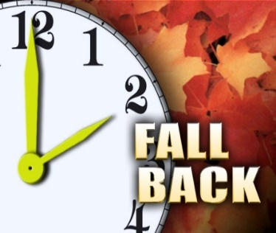
DON'T FORGET
Time Change - on Saturday night don't forget to turn your clocks back.

FALL BACK

2

COMMUNITY THANKSGIVING SERVICE
The Community Thanksgiving Service, with a combined choir, will be held at Fox Hill Central on Tuesday, November 20 at 7 PM. The Rev Kevin English, pastor at Wallace Memorial and retired elder from the Peninsula-Delaware Conference, will bring the message. Our offering will benefit H.E.L.P. Let us give thanks to God, for he is Good.

WHAT'S HAPPENING AT FOX HILL CENTRAL UNITED METHODIST CHURCH

FOX HILL HISTORICAL SOCIETY meeting will be Saturday, November 10 at 2 PM, at Fox Hill
Central UMC.

THE BOOK CLUB - The next book will be His Bright Light by Danielle Steel. Next meeting will be November 29 at 7 PM at the church. Everyone welcome, come join us!

JEAN RAINES CIRCLE - will not meet in November.

YOUTH - Will meet on November 11 at 5 PM.

SAMARITAN'S PURSE "OPERATION CHRISTMAS CHILD".
The Youth will be collecting items for shoe boxes for the Samaritan’s Purse “Operation Christmas Child”. Suggested items: Small toys (dolls, cars, puzzles, jump ropes); school supplies (pencils, rulers, crayons, color books); hygiene items (toothbrushes, bar soap, washcloths, soap); accessories (socks, hair bands, flip-flops, sunglasses); sticker/picture books; sewing kits; jewelry. Items not allowed: Used items; war-related toys (guns, knives, military figures); food/chocolate; aerosol cans; liquids or lotions; breakables. Collection day will be November 11, 2018. Please contact Cindy Roscopf at 757-329-8068 for more info."

BREAD OF LIFE - Come join us on Saturday, November 24, at 1030 AM. Lu Peterson, 933-3689

STEWARDSHIP will be doing monthly work days to help those in our church and community, if you have a need
or know of someone who does, please contact Alann Hudson.

NO WORK DAY SCHEDULED FOR NOVEMBER.

DEADLINE for the December 2018 issue of The WORD will be November 25.

3

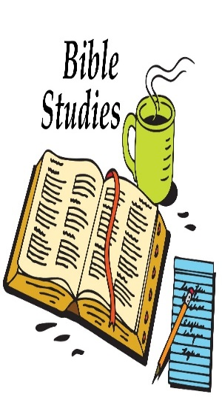
Friday Night Bible Study. Sam Joplin is teaching on Philippians. There will be a time of praise, prayer, Bible study and fellowship. All are welcome!
November 2, TBA
November 9, TBA
November 16, Trevoe Alston, 920-9751
November 23, Gayle Joplin, 851-4650
November 30, TBA

Wednesday Morning Bible Study meet every Wednesday at 10 AM.

Joyful Women of Faith meet the 1 and 3 Thursday of each month at 7 PM at the church

Pastor's Fall Bible Study - Life Changing Prayer by Jim Cymbala of the Brooklyn Tabernacle, will be held on Tuesdays at 10 AM and 7 PM beginning October 23 and running through the end of November. There will NOT be Bible study on November 20 as Fox Hill Central is hosting the community Thanksgiving service.

Any articles for this section forward to my email. Thanks Ruth

If you are unsure of what can be recycled, Hampton has a Curbside
Recycling Guide on the city website under Public Works.

ITEMS NEEDED FOR KITS
Thank you Fox Hill Congregation. With your help we can get this done. If you wish to donate cash, please give it to Alann Hudson. Again, Thank you. Lu Peterson
10 pencil charpeners 50 bars of soap
50 rulers 70 hand towels
55 scissors 70 wash clothes
10 crayons 100 finger nail clippers
30 sprial notebooks (one subject) 50 tooth brushes
170 bandaids
70 combs
90 2-gallon bags

FRANCIS ASBURY ELEMENTARY SCHOOL
BOX TOP$ FOR EDUCATION - The collection container is in the Social Hall.
PLASTIC BAGS - Donation boxes located in Sunday School Wing and by Back Door.

NIGHTS WELCOME - Thanksgiving Week - November 17 - 24.

4
BLESSING OF THE TOYS will be in December.

YOGA CLASS
During fall/winter, the Yoga Class will meet only on Mondays at 10 AM. If you are interested, please contact Rachel at 773-701-8729.

BREAKFAST WITH SANTA

NOVEMBER FLOWER CALENDAR
November 4, Butch Kilmon The Flower Calendar is posted on the Bulletin Board. If you
November 11, Betsy Griffin would like to place flowers in church for a special occasion
November 18, Case please check the calendar and write your name in the
November 25, Roscopf appropriate block. Thanks
The 2019 Flower Calendar is up on the corkboard at the back door of the Sanctuary. Please sign up.

5
PICTURES OF THE REVIVAL
(Courtesy of Tracy Andrus and Jan Spencer )
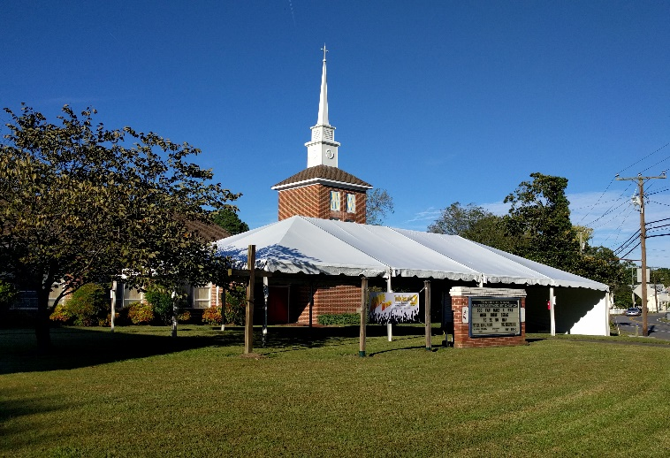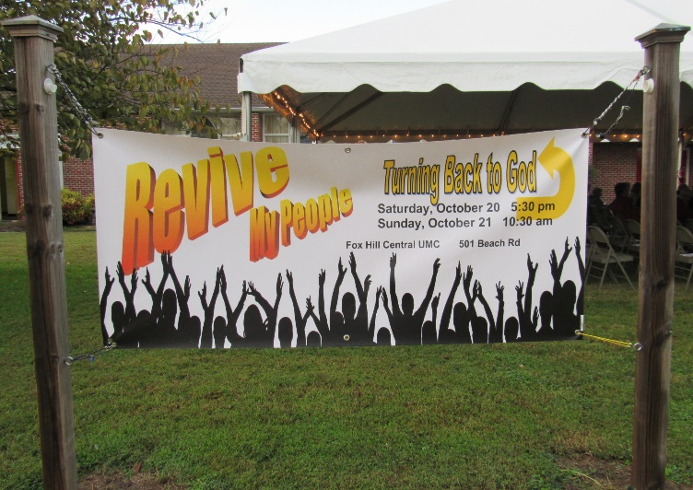

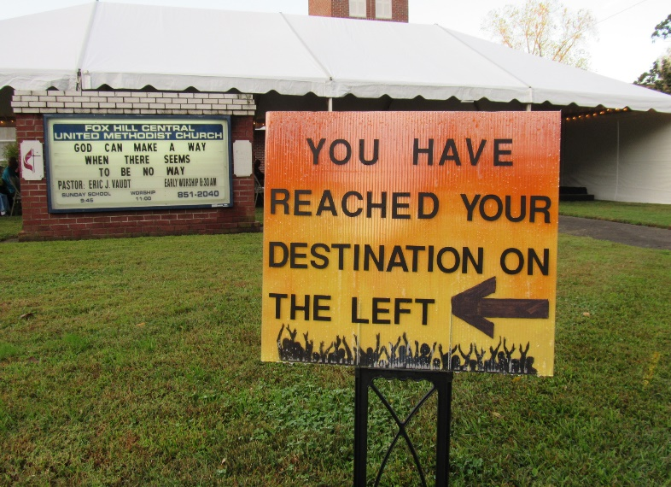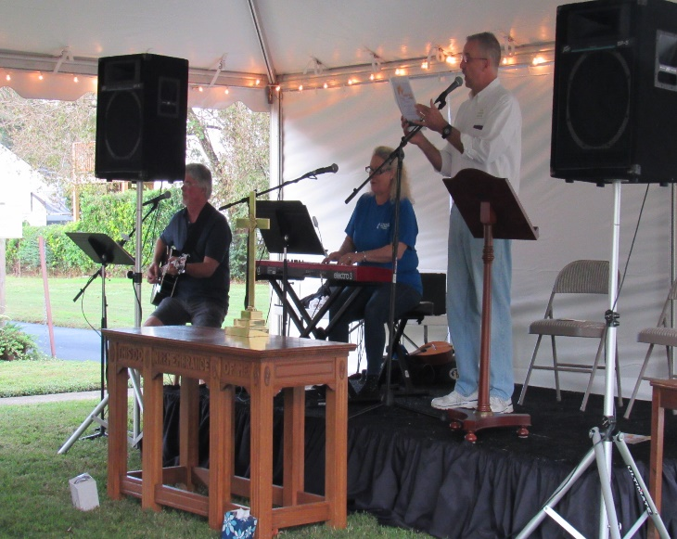

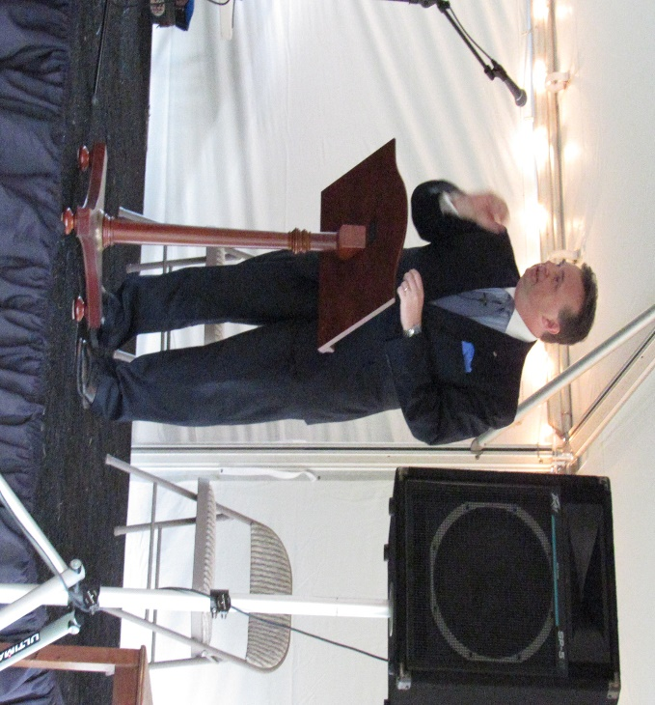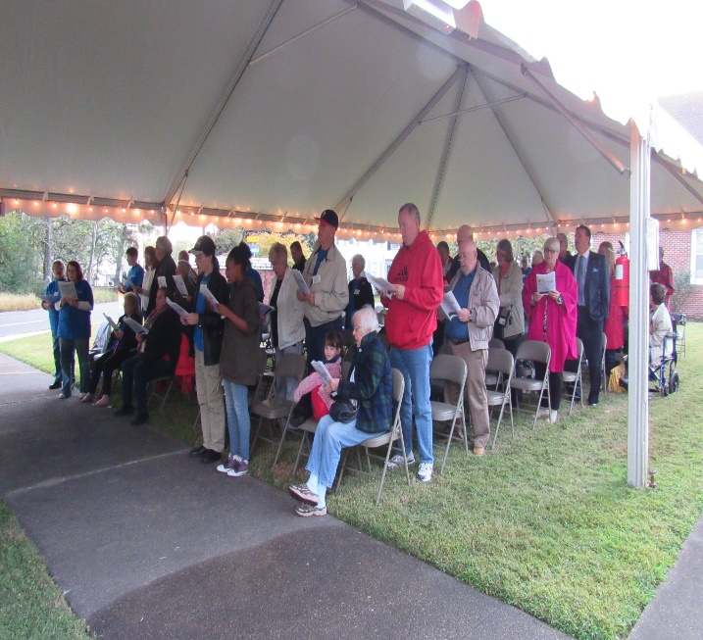

6
HALLOWEEN SAFETY STATION PICTURES
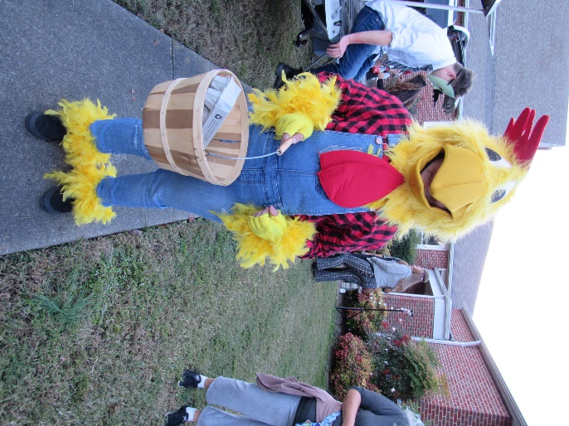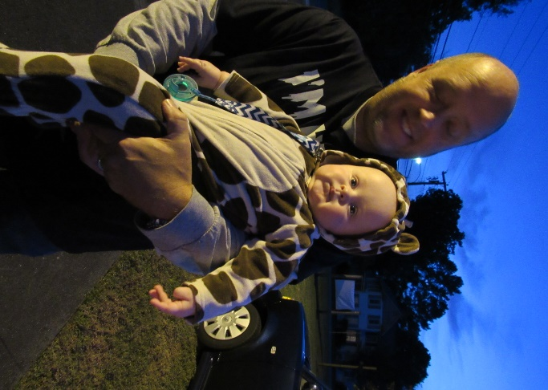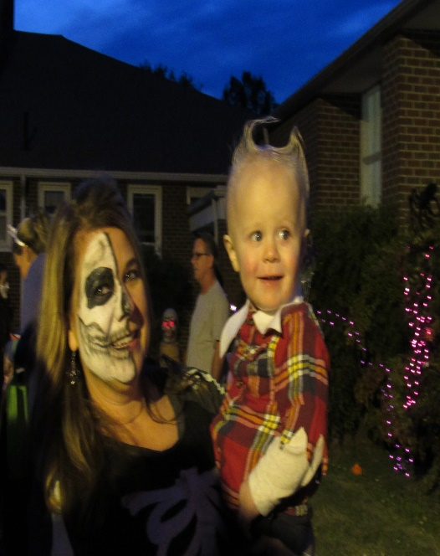
Brayden Wallace Brian Sheffler and Levi Cindy Roscopf and Royce Griffin

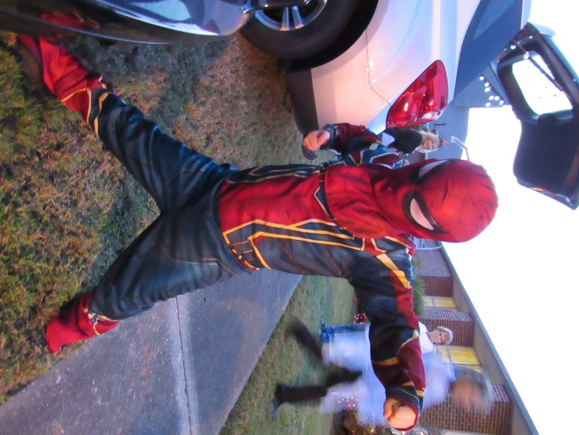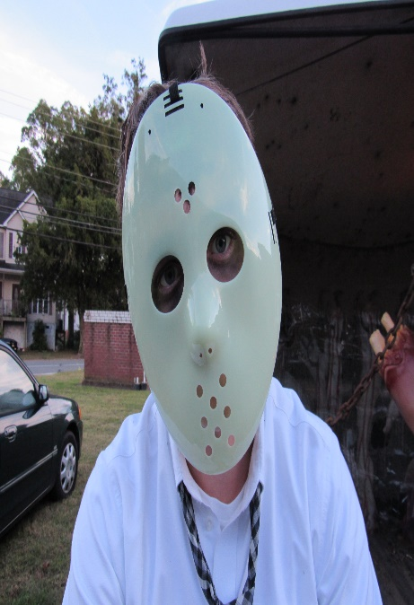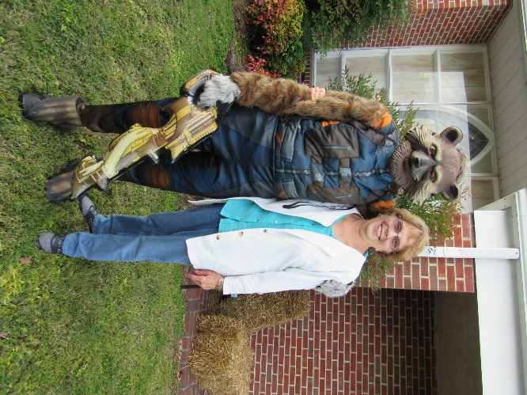
Easton Cagley Jakob Roscopf Sarah Woolsey and Alann Hudson
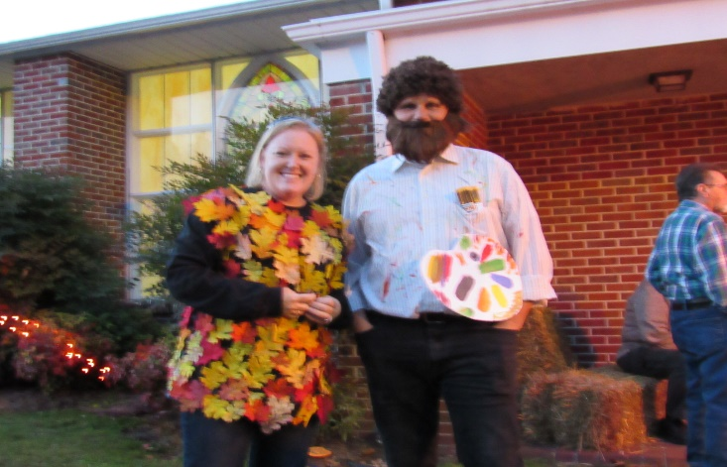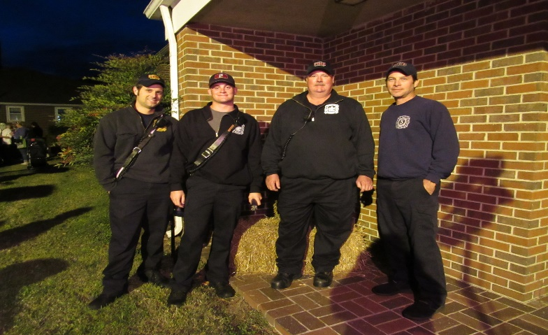
Kim and Tomy Cagley Firefighters from Fox Hill Statiob 5
7
NOVEMBER BIRTHDAYS
Madison Rowe November 2
Brandi Wallace November 3
Nancy Johnson November 4
Trish Allen November 5
Bob Bessette November 8
Lenny Wallace November 8
Mackenzie Brown November 8
Penny Sheffler November 9
Bobby Wills November 12
Morgan Walker November 19
Micaela Brown November 23
Phil Routten November 25
Mariah Pabst Roederer November 27
Julie Allen November 28
Cheryl Lewis Evans November 30
Sandra Pabst November 30

Mr. Phil Routten will be 93 on
November 25. Wishing Mr. Phil
a Happy Birthday!

NOVEMBER LAY LEADERS
November 4 Ushers P.J. Routten Bob Lay
Neall Forbes Orson Duhe
Greeter Trevoe Alston

November 11 Ushers Richard Roscopf Rocky Reichenbach
Carl Wallace Charlie Wallace
Greeters Alann Hudson and Tanya Mason

November 18 Ushers Tanya Mason Alann Hudson
Linda Melson Lu Peterson
Greeters P.J. and Wanda Routten

November 25 Ushers Rod Johnson Butch Kilmon
Teddy Cave Tom Cooke
Greeters George and Jessie Kay Black

Communion 1st and 3rd Sunday each month
Communion Ushers Butch Kilmon, P.J. Routten
Bell Ringer: Butch Kilmon Usher for Back Door: Freddie Rowe, Tommy Evans

8
NOVEMBER 2018 CALENDAR

Sunday | Monday | Tuesday | Wednesday | Thursday | Friday | Saturday
NOTE - Sunday Services
8:30 AM - Rise and Shine Service
9:45 AM - Sunday School
11:00 AM - Morning Worship Service
5:00 PM - Youth
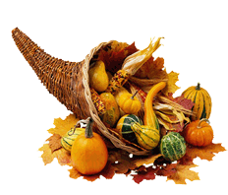 |  |  | 10 AM - Bible Study  7 PM - Choir Practice | 1  7 PM - Joyful  Women of Faith | 2  7 PM - Friday Night Bible Study -TBA | 3 |  | 24 | 25  10:00AM Bread of Life
4  See Note for  service times  Daylight Savings Time ends | 5 | 6  Election Day | 7  10 AM - Bible Study  7 PM - Choir Practice | 8 | 9  7 PM - Friday Night Bible Study - TBA | 10  2 PM - Fox Hill Historical Society
11  See Note for  service times  Veteran's Day | 12  7 PM - Administrative Council | 13 | 14  10 AM - Bible Study  7 PM - Choir Practice | 15  7 PM - Joyful Women of Faith | 16  7 P M - Friday Night Bible Study - Trevoe Alston | 17  Night's Welcome
18  See Note for  service times  Night's Welcome | 19  Night's Welcome | 20  7 PM - Combined Thanksgiving Service  Night's Welcome | 21  10 AM - Bible Study  7 PM Choir Practice  Night's Welcome | 22  Night's Welcome | 23  7 PM - Friday Night Bible Study-  Gayle Joplin  Night's Welcome | 24  1030 AM - Bread of Life
25  See Note for  service times | 26  1130 AM - Lunch Buddies | 27  10 AM and 7 PM – Pastors Fall Bible Study | 28  10 AM - Bible Study  7 PM - Choir Practice | 29  7 PM Book Club | 30  7 PM - Friday Night Bible Study - TBA
9
Fox Hill Central UMC
501 Beach Road
Hampton VA 23664

Return Service Requested

The WORD, November 2018

Fox Hill Central United Methodist Church E-mail - fhcumc@gmail.com
501 Beach Road Pastor E-mail - ericvaudt@vaumc.org
Hampton VA 23664 Office Hours: Monday - Thursday
(757) 851-2040 9:00 AM - 1:00 PM

Pastor Eric J. Vaudt, Cell (757) 759-7484
Administrative Assistant: Carole Anne Pabst
Music Director: Susan Heely
Custodian: Donna Coburn
Nursery: Cheryl McCrary and Rosemarie Kidd

10

